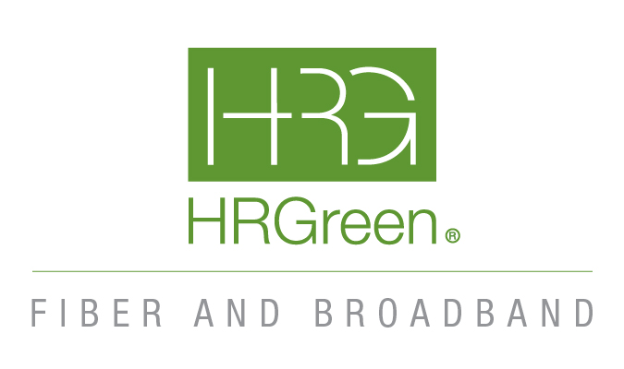
Grundy County Broadband Planning
Broadband Analysis and Feasibility Study Final Report



Ken Demlow & Monika Kazmierski
323 Alana Drive
New Lenox, IL 60451
Main: 319.841.4000+ Direct: 319.841.4323
kdemlow@hrgreen.com, monika.kazmierski@hrgreen.com

CONTENTS
Final Project Report 4
Executive Summary 4
Recommendations 5
GIS Map 7
Grundy County Broadband Market Assessment 10
Background 10
Inventory & Assessment of Broadband Assets 11
Residential and Business Service Providers Overview 15
Residential Internet Service Providers in the Grundy County Service Area 18
Business Internet Service Providers in the Grundy County Service Area 21
Internet Service Providers in Grundy County Communities 24
Comcast (Xfinity) 24
Frontier 24
HughesNet 25
Kraus 25
Maxwire 26
Mediacom 27
NewArkNet Wireless 27
Rise Broadband 28
Spectrum (Charter Communications, Inc.) 28
Surf Internet 29
Starlink 29
T-Mobile 5G Home Internet 30
Verizon 5G Home Internet 30
Watch Communications 31
Engagement Results and Gap analysis 32
Executive Summary 32
Broadband issues in Grundy county 32
Potential Broadband Resources in Grundy county 33
Background Information 33
Stakeholder interviews 36
Stakeholders 37
Municipal Leadership 37
Anchor Institutions 37
Community Foundation of Grundy County 37
Businesses 37
Education 37
EMS & Medical 37
Libraries 37
Regional Leadership 38
Key Findings 38
Gap Analysis Appendix of Questionaires 48
Visioning Session 54
Options to Improve Broadband – High-Level Design 57
ISP Relationships and partnership opportunities 63
Policy Review and Suggestion 65
Appendix A – Glossary of Broadband Terms 67

Final Project Report

Executive Summary
The context for this Broadband Analysis and Feasibility Study for Grundy County is that it is a component of the Grundy County Nuclear Host Community Economic Resiliency Strategy, or the “Grundy Resiliency Project,” funded by the U.S. Department of Commerce Economic Development Administration (EDA) and Grundy County. Broadband and connectivity are key aspects of the future of every community. Many aspects of our utilities, commerce, education, healthcare, safety, communication and life activities rely on some form of connectivity. Therefore, the resiliency of our connectivity and broadband systems is an important topic that needs to be analyzed and addressed in a larger resiliency plan.

In HR Green’s research and analysis, two key aspects of broadband and connectivity in Grundy County developed as the most significant topics to address:
- Broadband – networks for homes and businesses – the key question is whether homes and businesses have the broadband they need
- Connectivity Resiliency – the significant question in this category is if there are resilient networks in place to provide connectivity for all communications needs (public and private) now and into the future

The findings of the study are mixed for both categories. Results show that citizens, businesses anchor institutions and public agencies appear to have taken the steps that were needed to achieve the basic connectivity required to accomplish what they have to do. There are not a lot of complaints regarding connectivity, but maps show that there are areas within the County that do not have good broadband (there are addresses that do not meet the minimum 100/10 Mbps – for clarifications of these terms, please see the Glossary in Appendix A), and some stakeholders discuss broadband problems.

The maps are from the Federal Communications Commission (FCC). The FCC derives them from their 477 (see the Glossary for more information about this filing), therefore they are based on reporting by Internet Service Providers (ISPs). Stakeholder discussions in some ways corroborated the FCC maps (some stakeholders reported internet problems that coincided with the maps) and in other ways were not as strongly supportive of the FCC maps as might have been expected (with ISP reported lack of coverage, there are often many complaints about service).

Therefore, regarding the first category (broadband), there appear to be challenges, but it also seems that most basic needs are covered in some way that seems to be a patchwork of technologies (some fiber (possibly), cable, copper, DSL, fixed wireless and satellite – for more information on these technologies, see the Glossary in Appendix A).

However, this patchwork of basic coverage is not a good plan for resiliency (the second category). The appetite and need for capacity and speed for transmitting data grows dramatically every year. Smart applications for safety, delivery of government services, business uses, healthcare, etc. are and will rapidly increase. A patchwork of older technologies cannot be expected to keep up with these needs. Consumers may continue to make do, but that is not a good plan for true resiliency.

Part of this study was also a review of Grundy County’s broadband related policies. Although HR Green did not find ordinances that would be expected to inherently inhibit broadband expansion, there are some policy aspects that could be improved. Most notably, there are many roads in the County that do not have Right of Way (ROW) – property owners property extends to the center line of the road. This presents a particular problem for ISPs, but there appear to be ways to address this significant issue. HR Green also provides some other policy recommendations in the policy section that are not as critical as dealing with ROW, but could have impact on future broadband expansion and improvement.

There are challenges in Grundy County (which are discussed more thoroughly in the Gap Analysis section), but there are also good resources. Because of these resources and potential opportunities, the options for the future are not bleak – they will require coordination and further development to overcome the status quo (which could put the County in the position of being digitally left behind.

Recommendations
To formulate a plan to utilize the available resources, HR Green makes the following recommendations:
- Broadband Committee: There is a significant amount of coordination that can continue to be done – townships, County highway, cities, other County departments, ISPs, energy utilities, etc. Having an active committee can help plan the communications to explore options
- Utilize The High-Level Design (HLD) Map: As part of this study, an HLD was completed for southwest quadrant of the County. The HLD details road segments and costs for conduit and fiber throughout this part of the County. As broadband is placed in each segment, it can be marked as having broadband (for example if ComEd communicates they have extra fiber capacity on their poles on that section). Using this tool, the County can track progress of broadband proliferation and help focus efforts on segments that can still need attention
- ComEd: Because there are many properties that own up to the street center line (no public ROW), ComEd can help with fiber distribution. They have excess fiber capacity on some of their poles and are open to it being utilized for broadband. This needs to be verified, but it appears that as long as their existing fiber is being utilized by ISPs, there are not ROW issues
- Acquire ROW: When the County, County Highway and Townships can acquire ROW, the problem of having to get a utility easement from each property owner. That would make fiber distribution (the most resilient) much more possible
- Polices: in the Policy section of this report, HR offers several policy recommendations. One of the more significant recommendations is: Dig Once. Whenever any utility (public or private) or road construction are done that could include broadband infrastructure (conduit or fiber), HR Green recommends having “Dig Once” policies in place that require a process to determine if it is feasible to place conduit or fiber during the construction (this dramatically reduces the cost and could possibly help with the ROW issue)
- Grants: Depending on how the last BEAD grants are awarded, there could still be grants for broadband and connectivity in SW Grundy County. Working with ISPs or determining grants the County could consider, could help bring funds for broadband expansion
- Publicly Owned Ring: Having a publicly owned ring for government purposes (connecting facilities, traffic signals, smart connectivity and providing “middle mile” for networks
- Regular ISP Meetings: Having a regular meeting with ISPs could be beneficial. Talking with them about needs and their potential plans can help in coordination of middle mile and extensions

To develop these findings and recommendations, HR Green provided the following research and analysis:
- Kickoff
- GIS Map
- Market Assessment
- Engagement Plan
- Gap Analysis
- Visioning
- HLD
- ISP Relationships and partnership opportunities
- Policy/Permit Proc. Review

The details of our research and analysis are in the following sections of this report.

GIS Map
HR Green developed a GIS map to display the data that was developed during research and analysis. The County’s GIS person was instrumental in providing data the County has.

The data included grant eligible locations:

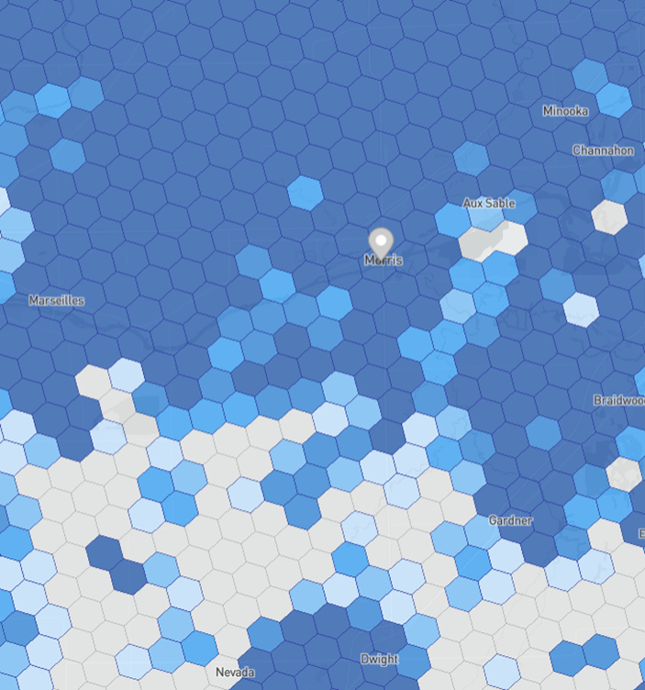

Figure 1 - Grant Eligile Locations in Grundy County

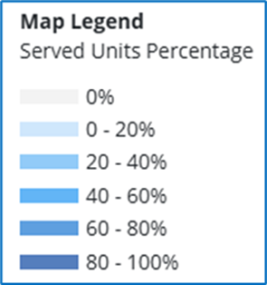

Grant eligibility data can be displayed in several different formats. The above is a higher-level representation to show areas that are not eligible. In the high-level design section of this report, actual addresses were used in the map to design an actual high-level network.

Wind farm assets in and outside Grundy County:

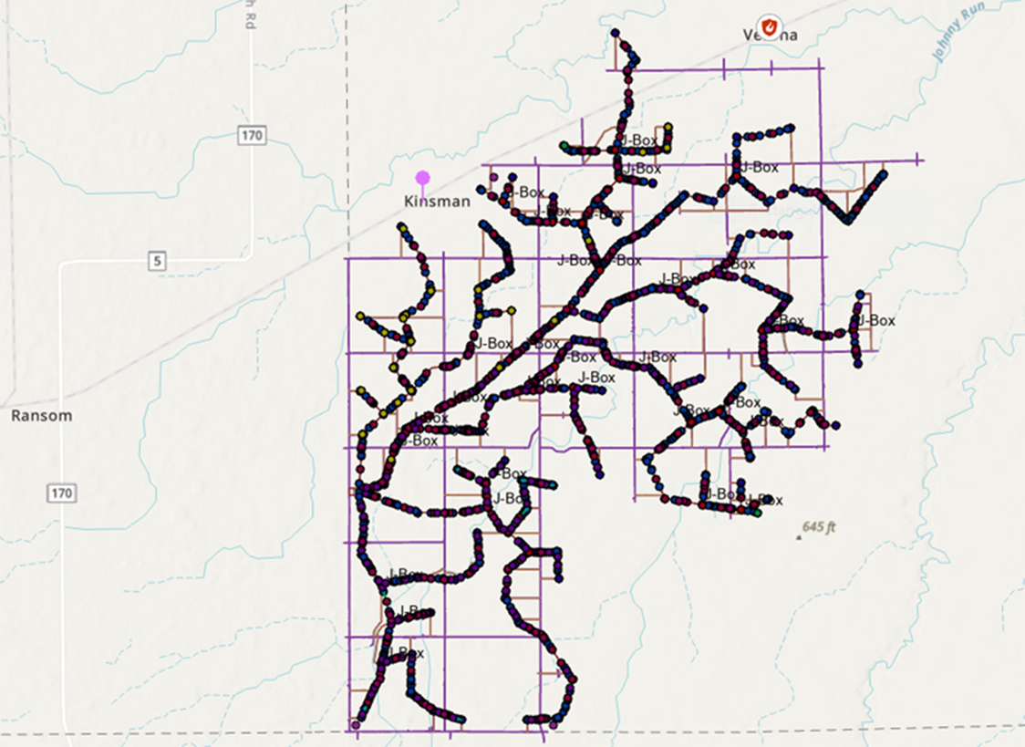

Figure 2 - Wind Farm Assets

Through GIS, HR Green was also able to pull data together to show their locations in relation to each other. The below map shows several data points wind turbines, State maintained roads, County maintained roads, township-maintained roads and turbine access roads.

The main purpose of the GIS map is to provide a repository for geospatial information so that it can be analyzed for those efforts to be used in subsequent deliverables.

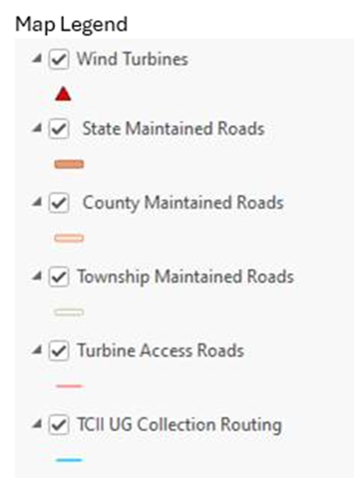
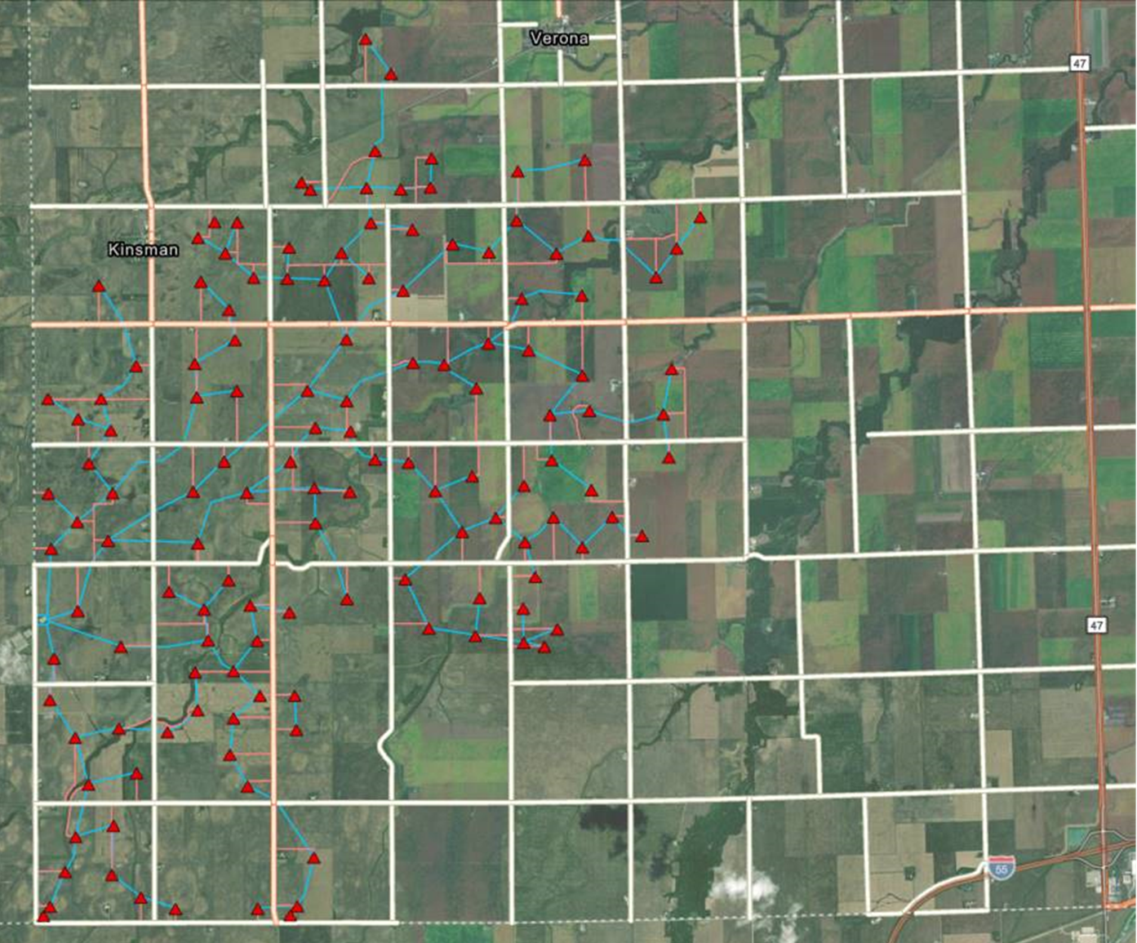

Figure 3 - Combined Map of Roads and Turbine Assets

Grundy County Broadband Market Assessment

Background
The significance of broadband coverage has evolved from a mere convenience to a necessity. Many employment opportunities and lifestyle elements, such as education, remote work, economic growth, telemedicine, and more, now rely heavily on robust internet connectivity. Analyzing the competitive landscape of broadband coverage, however, poses considerable challenges due to the ever-changing nature of market dynamics, pricing structures, product offerings, and disparities across different sectors.
The initial step in comprehending the broadband landscape within a community involves delving into industry-reported data. This journey begins with a comprehensive Market Assessment, which entails an in-depth analysis of data provided by internet service providers (ISPs) regarding their coverage areas. The analysis commences with a comprehensive examination, cataloging, and detailed documentation of the service offerings from each primary provider in the communities comprising Grundy County.
As part of their licensing obligations, providers are mandated to report specific data related to their customer base. This data is typically accessible through the Federal Communications Commission (FCC) and other supplementary sources that offer further insights into the broadband ecosystem.
It is important to acknowledge the inherent flaws within this data. These shortcomings include exclusive data for reporting requirements. The public has access to the data within the Broadband Data Collection (BDC) reports, but only providers and some types of outside entities have full access to the back-end data necessary for an in-depth market analysis. In addition, reporting and display cycles can render the submitted information outdated before it becomes available for analysis. There are also limited consequences for inaccurate reporting and data entry errors and some providers may have secondary motives to exaggerate their coverage, as it could affect their competitors’ eligibility for grants. In addition, data is recorded at the census block level, potentially masking variations within that area when data is pulled to represent an entire block.
However, this data serves as the foundational dataset for further analysis. It is also pivotal in securing federal and state grants. Finding and correcting errors is imperative for fair distribution of resources.
Given these data challenges, a high-level Market Assessment cannot be solely relied upon. Instead, it serves as a starting point for understanding coverage and identifying areas that necessitate validation against other sources of data. A word of caution is essential: conducting a market analysis without obtaining real-world feedback may lead to substantial inaccuracies. To cross-reference the Market Assessment results, HR Green will conduct stakeholder interviews, which will be discussed in another chapter within this report. Such feedback illuminates not only the actual practices of providers, but also pricing structures, customer satisfaction levels, and identifies unmet demands or underserved segments of the market.

Inventory & Assessment of Broadband Assets
Through the collecting and analyzing of the key ISP data, there are some important findings to understand and either verify or challenge. First, HR Green will discuss key findings, then present the backup information.

There are different technologies that are utilized to provide broadband services. They vary in several categories. This is not an exhaustive list, but provides some insights into technology limitations:
- Capacity: The amount of data that can be carried is different based on several factors (equipment, number of users at a time, distance the data travels, etc.). Fiber provides the greatest capacity if it is installed correctly and depending on what equipment is installed on the ends. Other technologies can currently approach the capacity of fiber, depending on the equipment they provide, but can be greatly impacted by conditions, users and distance.
- Speed: Similar to capacity, fiber offers the greatest speeds (depending on equipment). Also, similar to capacity, conditions and users can greatly impact performance in other technologies. Copper and cable are also more limited by distance than fiber.
- Resiliency: Buried fiber has the greatest resiliency. If it is on poles, it can be subject to external conditions much like other technologies.

Key Findings:

- There appear to be underserved addresses in Grundy County. Working with ISPs to develop a plan to serve those addresses with the best technology possible will be important to future sustainability in the County.
- There are a mix of technologies, some of which may not future proof the County (have adequate infrastructure for future capacity and speed needs of county stakeholders).To have the best infrastructure for the future, the County will want to focus on fiber, where possible.
- There are 6 ISPs who provide wireline service. In stakeholder meetings, it will be important to discuss which of these have or are planning on installing fiber (as opposed to copper or cable).
- There are 14 ISPs in Grundy County communities, which all offer residential service. Although they offer different technologies, this is a substantial amount of ISPs to collaborate with.
- There are 16 residential internet options in the Grundy County service area from 14 residential ISPs (some ISPs offer more than one option).
- 11 of the 14 internet providers in Grundy County communities offer business service.
- There are 12 business internet options in the Grundy County service area from 11 business ISPs.
- Approximately 94% of zip codes have internet options from more than one provider. The exception to this is zip code 60479. This is a good basis to build from for reaching unserved, building sustainability and keeping costs as low as possible. Having said that, zip code 60479 will need to be further evaluated to see if the data is correct and what options there are to build better broadband capacity.

The map below shows the addresses in Grundy County. The red dots show what is reported by ISPs as unserved. There appear to be a significant number of unserved locations. Depending on grant programs, these addresses should be eligible for grant funding. As the grant programs are defined, it will be important to work with ISPs to discuss which addresses can be served with fiber to continue building out a fiber-rich infrastructure. Grant programs may or may not support those aspirations, but fiber should be part of the discussions.

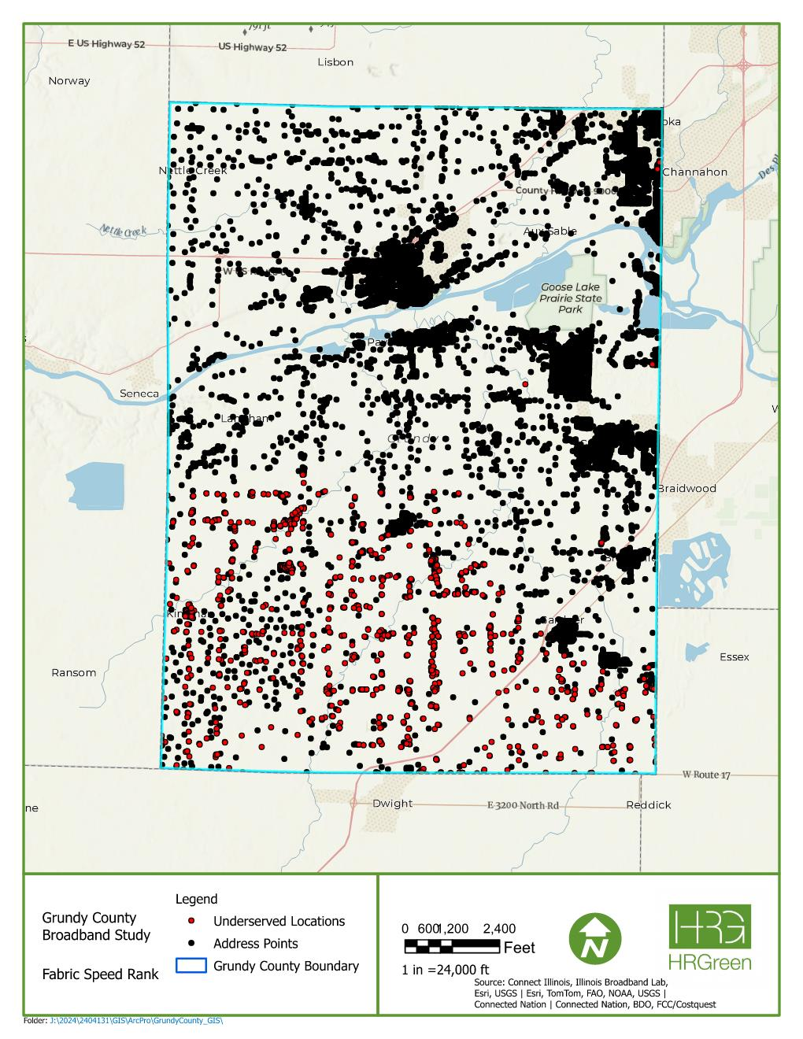

MAP 1 – ADDRESSES WITH UNDERSERVED LOCATIONS HIGHLIGHTED

In addition, the map below provides insight into which provider is serving which address within Grundy County. Note that this information is generalized per area as it is not address- specific. However, it adds additional insight into understanding which provider should be approached for the benefit of Grundy County residents for future funding opportunities to improve broadband connectivity in the area.
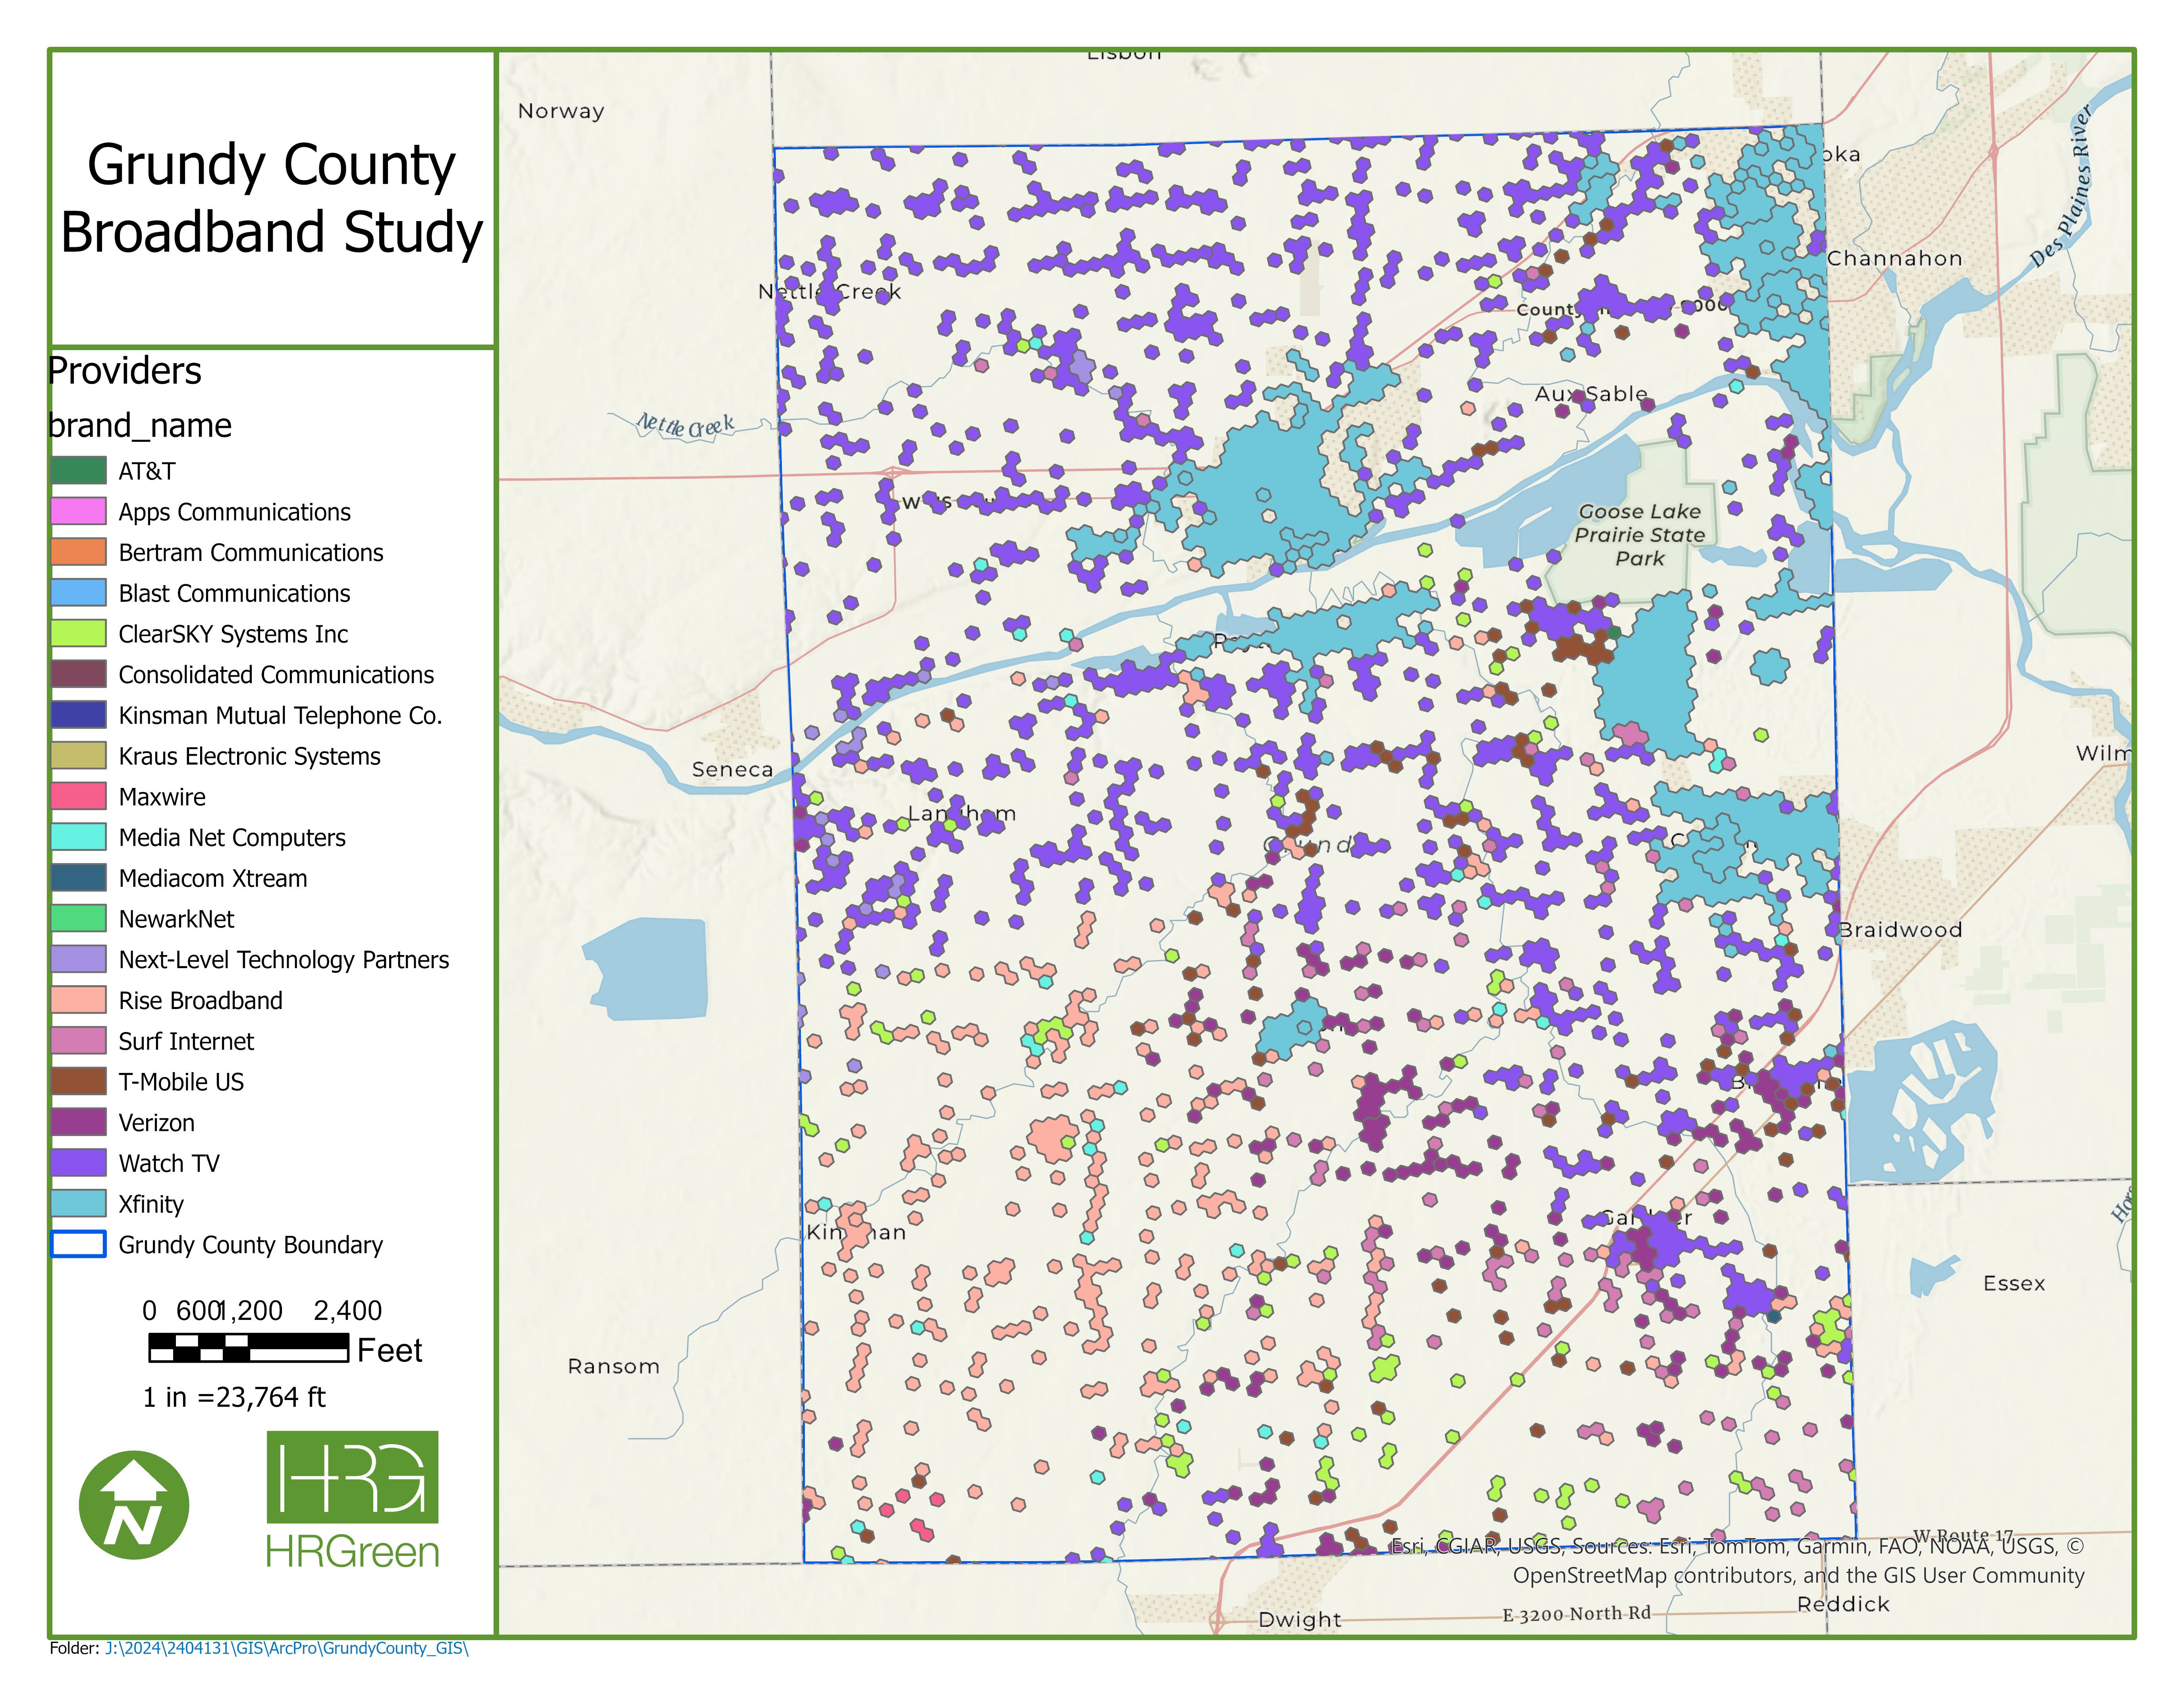
MAP 2 – INTERNET SERVICE COVERAGE BY ADDRESS

The data presents interesting observations. There are clearly some areas of the County that lack infrastructure to support broadband-quality internet service, including the southern end of the County that particularly stands out. These signify that there is a lack of effective fiber infrastructure located in those vicinities and should be a priority on the list for project sites to improve broadband in Grundy County.

Residential and Business Service Providers Overview
The residents and businesses in Grundy County communities can obtain internet access services from a variety of ISPs and wireless internet service providers (WISPs) via Digital Subscriber Line (DSL) (over copper), cable, fiber, satellite, fixed wireless, and mobile wireless. This assessment focused on 28 internet service options from a total of 14 providers that offer services to 5% or more of the residents and/or businesses within zip code limits.
- 6 Wired Internet Service Providers (DSL/Cable/Fiber): Comcast, Frontier, Kraus, Mediacom, Spectrum (Charter), Surf Internet
- 2 Mobile Wireless Internet Service Providers: T-Mobile 5G Home Internet and Verizon 5G Home Internet
- 2 Satellite Internet Service Providers: HughesNet and Starlink
- 5 Fixed Wireless Internet Service Providers: Maxwire, NewarkNet Wireless, Rise Broadband, Surf Internet, and Watch Communications
Additional data was drawn from the websites of each ISP, as well as some of the data was drawn from the following dedicated websites.
- All Connect (https://www.allconnect.com)
- Broadband Now (https://broadbandnow.com)
- Broadband Search (https://www.broadbandsearch.net)
- Business Internet (https://businessinternet.com)
- High Speed Internet (https://www.highspeedinternet.com)
- In My Area (https://www.inmyarea.com)

The following ISPs and WISPs are available for residents and businesses in Grundy County’s service area:
- Comcast
- Frontier
- Hughesnet
- Kraus
- Maxwire
- Mediacom
- NewarkNet Wireless
- Rise Broadband
- Spectrum (Charter)
- Starlink
- Surf Internet
- T-Mobile 5G Home Internet
- Verizon 5G Home Internet
- Watch Communications

Note that this Market Assessment used a zip code analysis to determine ISP availability and coverage. There may be select ISPs which may have service in the same zip code as Grundy County, but did not actually service the County. As such, these were excluded. In addition, further discussions with Grundy County staff indicated the significance of several additional ISPs which were not included in this analysis but provide service in surrounding communities and are of importance to the County to include in future discussions. These ISPs include:

- Conxxus
- Heartland Cable Broadband
- KWISP Internet
- Mid Century Fiber
- Nextlink Internet
- Stratus Networks
- Tonica Telephone Co

Although these ISPs are not included in this Market Assessment analysis, they will be included in future stakeholder discussions.

The analysis of providers is done on a zip code basis. HR Green utilized the following zip codes for our analysis.

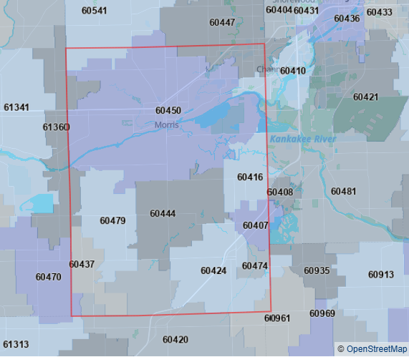
MAP 3 – ZIP CODES IN GRUNDY COUNTY

Residential Internet Service Providers in the Grundy County Service Area
This assessment focused on 16 residential internet options in Grundy County from 14 residential internet providers. The tables below list the residential ISPs and WISPs in Grundy County communities and identifies the type of service provided. Due to the large volume of ISPs, the data has been divided into two tables. Note that certain zip codes span areas outside of the County and may not necessarily provide all listed services within the County.

Zip Code | Comcast (Xfinity)  Coverage, Provider Type | Frontier  Coverage, Provider Type | Hughesnet  Coverage, Provider Type | Kraus  Coverage, Provider Type | Maxwire  Coverage, Provider Type | Mediacom (Xtream)  Coverage, Provider Type | NewarkNet Wireless  Coverage, Provider Type
60407 | N/A | N/A | 100.0%  Satellite, Satellite/Fixed Wireless | N/A | N/A | 81.8%  Cable/Fiber | N/A
60410 | 98.1%  Cable | N/A | 100.0%  Satellite, Satellite/Fixed Wireless | N/A | N/A | N/A | N/A
60416 | 95.2%  Cable | N/A | 100.0%  Satellite, Satellite/Fixed Wireless | N/A | N/A | N/A | N/A
60420 | N/A | N/A | 100.0%  Satellite, Satellite/Fixed Wireless | N/A | 12.7%  Fixed Wireless | 78.6%  Cable/Fiber | N/A
60424 | N/A | N/A | 100.0%  Satellite, Satellite/Fixed Wireless | 73.8%  Cable | N/A | 14.7%  Cable/Fiber | N/A
60437 | N/A | N/A | 100.0%  Satellite, Satellite/Fixed Wireless | N/A | 38.5%  Fixed Wireless | N/A | N/A
60444 | 47.6%  Cable | N/A | 100.0%  Satellite, Satellite/Fixed Wireless | N/A | N/A | N/A | N/A
60447 | 79.2%  Cable | N/A | 99.9%  Satellite, Satellite/Fixed Wireless | N/A | N/A | N/A | N/A
60450 | 80.3%  Cable | N/A | 99.9%  Satellite, Satellite/Fixed Wireless | N/A | N/A | N/A | N/A
60451 | 28.3%  Cable | N/A | 100.0%  Satellite, Satellite/Fixed Wireless | N/A | N/A | N/A | 79.0%  Fixed Wireless
60470 | N/A | N/A | 100.0%  Satellite, Satellite/Fixed Wireless | N/A | 33.7%  Fixed Wireless | N/A | N/A
60474 | N/A | N/A | 100.0%  Satellite, Satellite/Fixed Wireless | N/A | N/A | 95.8%  Cable/Fiber | N/A
60479 | N/A | N/A | 100.0%  Satellite, Satellite/Fixed Wireless | N/A | N/A | N/A | N/A
60481 | 74.7%  Cable | N/A | 97.8%  Satellite, Satellite/Fixed Wireless | N/A | N/A | N/A | N/A
60961 | N/A | 89.1%  DSL, Fiber | 100.0%  Satellite, Satellite/Fixed Wireless | N/A | N/A | N/A | N/A
61360 | N/A | N/A | 100.0%  Satellite, Satellite/Fixed Wireless | 77.7%  Cable | N/A | N/A | N/A
Table 1: Residential Internet Options

Zip Code | Rise Broadband  Coverage, Provider Type | Spectrum  Coverage, Provider Type | Starlink  Coverage, Provider Type | Surf Internet  Coverage, Provider Type | T-Mobile 5G Home Internet  Coverage, Provider Type | Verizon 5G Home Internet  Coverage, Provider Type | Watch Communications  Coverage, Provider Type
60407 | 39.7%  Fixed Wireless | 33.0%  Cable | 100.0%  Satellite | 5.4%  Fixed Wireless, Fiber | 70.1%  Mobile Wireless | 21.3%  Mobile Wireless | 29.0%  Fixed Wireless
60410 | N/A | 33.0%  Cable | 100.0%  Satellite | 18.5%  Fixed Wireless, Fiber | 55.2%  Mobile Wireless | 18.0%  Mobile Wireless | 85.7%  Fixed Wireless
60416 | 16.4%  Fixed Wireless | 33.0%  Cable | 100.0%  Satellite | 78.6%  Fixed Wireless, Fiber | 59.2%  Mobile Wireless | N/A | 70.8%  Fixed Wireless
60420 | N/A | 33.0%  Cable | 99.9%  Satellite | N/A | 8.6%  Mobile Wireless | 11.8%  Mobile Wireless | 54.9%  Fixed Wireless
60424 | 63.8%  Fixed Wireless | 33.0%  Cable | 99.7%  Satellite | 63.6%  Fixed Wireless, Fiber | 10.5%  Mobile Wireless | N/A | 39.8%  Fixed Wireless
60437 | 78.7%  Fixed Wireless | 33.0%  Cable | 100.0%  Satellite | N/A | N/A | N/A | N/A
60444 | 79.5%  Fixed Wireless | 33.0%  Cable | 100.0%  Satellite | 50.0%  Fixed Wireless, Fiber | 32.7%  Mobile Wireless | 7.9%  Mobile Wireless | 21.4%  Fixed Wireless
60447 | N/A | 33.0%  Cable | 100.0%  Satellite | 26.8%  Fixed Wireless, Fiber | 64.7%  Mobile Wireless | 9.3%  Mobile Wireless | 85.0%  Fixed Wireless
60450 | 43.2%  Fixed Wireless | 33.0%  Cable | 99.9%  Satellite | 14.4%  Fixed Wireless, Fiber | 14.6%  Mobile Wireless | 6.7%  Mobile Wireless | 84.5%  Fixed Wireless
60451 | 44.0%  Fixed Wireless | 33.0%  Cable | 99.9%  Satellite | N/A | 76.0%  Mobile Wireless | 40.0%  Mobile Wireless | 77.1%  Fixed Wireless
60470 | 88.7%  Fixed Wireless | 33.0%  Cable | 100.0%  Satellite | N/A | N/A | N/A | N/A
60474 | 54.7%  Fixed Wireless | 33.0%  Cable | 100.0%  Satellite | 9.7%  Fixed Wireless, Fiber | N/A | N/A | 58.7%  Fixed Wireless
60479 | 98.2%  Fixed Wireless | 33.0%  Cable | 100.0%  Satellite | N/A | 7.4%  Mobile Wireless | N/A | 19.6%  Fixed Wireless
60481 | N/A | 33.0%  Cable | 99.9%  Satellite | 39.5%  Fixed Wireless, Fiber | 49.9%  Mobile Wireless | 19.9%  Mobile Wireless | 36.5%  Fixed Wireless
60961 | 18.8%  Fixed Wireless | 33.0%  Cable | 99.8%  Satellite | 25.5%  Fixed Wireless, Fiber | 6.4%  Mobile Wireless | N/A | N/A
61360 | 65.2%  Fixed Wireless | 33.0%  Cable | 99.9%  Satellite | N/A | 82.8%  Mobile Wireless | N/A | 32.3%  Fixed Wireless
Table 2: Residential Internet Options Continued

Business Internet Service Providers in the Grundy County Service Area
This assessment focused on 12 business internet options in Grundy County from 11 business internet providers. The table below lists the business ISPs and WISPs in Grundy County communities and identifies the type of service provided. Due to the large volume of ISPs, the data has been divided into two tables. Note that certain zip codes span areas outside of the County and may not necessarily provide all listed services within the County.
Zip Code | Comcast (Xfinity)  Coverage, Provider Type | Hughesnet  Coverage, Provider Type | Kraus  Coverage, Provider Type | Maxwire  Coverage, Provider Type | Mediacom (Xtream)  Coverage, Provider Type | NewarkNet Wireless  Coverage, Provider Type
60407 | N/A | 100.0%  Satellite, Satellite/Fixed Wireless | N/A | N/A | 81.8%  Cable/Fiber | N/A
60410 | 98.1%  Cable | 100.0%  Satellite, Satellite/Fixed Wireless | N/A | N/A | N/A | N/A
60416 | 95.2%  Cable | 100.0%  Satellite, Satellite/Fixed Wireless | N/A | N/A | N/A | N/A
60420 | N/A | 100.0%  Satellite, Satellite/Fixed Wireless | N/A | 86.3%  Fixed Wireless, Fiber | 78.6%  Cable | N/A
60424 | N/A | 100.0%  Satellite, Satellite/Fixed Wireless | 73.8%  Cable | N/A | 14.7%  Cable/Fiber | N/A
60437 | N/A | 100.0%  Satellite, Satellite/Fixed Wireless | N/A | 38.5%  Fixed Wireless | N/A | N/A
60444 | 47.6%  Cable | 100.0%  Satellite, Satellite/Fixed Wireless | N/A | N/A | N/A | N/A
60447 | 79.2%  Cable | 99.9%  Satellite, Satellite/Fixed Wireless | N/A | N/A | N/A | N/A
60450 | 80.3%  Cable | 99.9%  Satellite, Satellite/Fixed Wireless | N/A | N/A | N/A | N/A
60451 | 28.3%  Cable | 100.0%  Satellite, Satellite/Fixed Wireless | N/A | N/A | N/A | 79.0%  Fixed Wireless
60470 | N/A | 100.0%  Satellite, Satellite/Fixed Wireless | N/A | 33.7%  Fixed Wireless | N/A | N/A
60474 | N/A | 100.0%  Satellite, Satellite/Fixed Wireless | N/A | N/A | 95.8%  Cable/Fiber | N/A
60479 | N/A | 100.0%  Satellite, Satellite/Fixed Wireless | N/A | N/A | N/A | N/A
60481 | 74.7%  Cable | 97.8%  Satellite, Satellite/Fixed Wireless | N/A | N/A | N/A | N/A
60961 | N/A | 100.0%  Satellite, Satellite/Fixed Wireless | N/A | N/A | N/A | N/A
61360 | N/A | 100.0%  Satellite, Satellite/Fixed Wireless | 77.7%  Cable | N/A | N/A | N/A
Table 3: Business Internet Options

Zip Code | Rise Broadband  Coverage, Provider Type | Starlink  Coverage, Provider Type | Surf Internet  Coverage, Provider Type | T-Mobile 5G Home Internet  Coverage, Provider Type | Watch Communications  Coverage, Provider Type
60407 | 39.7%  Fixed Wireless | 100.0%  Satellite | 5.4%  Fixed Wireless, Fiber | 76.7%  Mobile Wireless | 29.0%  Fixed Wireless
60410 | N/A | 100.0%  Satellite | 18.5%  Fixed Wireless, Fiber | 61.1%  Mobile Wireless | 85.7%  Fixed Wireless
60416 | 16.4%  Fixed Wireless | 100.0%  Satellite | 78.6%  Fixed Wireless, Fiber | 63.3%  Mobile Wireless | 70.8%  Fixed Wireless
60420 | N/A | 99.9%  Satellite | N/A | 8.1%  Mobile Wireless | 54.9%  Fixed Wireless
60424 | 63.8%  Fixed Wireless | 99.7%  Satellite | 63.6%  Fixed Wireless, Fiber | 23.3%  Mobile Wireless | 39.8%  Fixed Wireless
60437 | 78.7%  Fixed Wireless | 100.0%  Satellite | N/A | 10.4%  Mobile Wireless | N/A
60444 | 79.5%  Fixed Wireless | 100.0%  Satellite | 50.0%  Fixed Wireless, Fiber | 64.5%  Mobile Wireless | 21.4%  Fixed Wireless
60447 | N/A | 100.0%  Satellite | 26.8%  Fixed Wireless, Fiber | 66.2%  Mobile Wireless | 85.0%  Fixed Wireless
60450 | 43.2%  Fixed Wireless | 99.9%  Satellite | 14.4%  Fixed Wireless, Fiber | 14.7%  Mobile Wireless | 84.5%  Fixed Wireless
60451 | 44.0%  Fixed Wireless | 99.9%  Satellite | N/A | 76.7%  Mobile Wireless | 77.1%  Fixed Wireless
60470 | 88.7%  Fixed Wireless | 100.0%  Satellite | N/A | 5.2%  Mobile Wireless | N/A
60474 | 54.7%  Fixed Wireless | 100.0%  Satellite | 9.7%  Fixed Wireless, Fiber | N/A | 58.7%  Fixed Wireless
60479 | 98.2%  Fixed Wireless | 100.0%  Satellite | N/A | 14.3%  Mobile Wireless | 19.6%  Fixed Wireless
60481 | N/A | 99.9%  Satellite | 39.5%  Fixed Wireless, Fiber | 47.4%  Mobile Wireless | 36.5%  Fixed Wireless
60961 | 18.8%  Fixed Wireless | 99.8%  Satellite | 25.5%  Fixed Wireless, Fiber | 8.5%  Mobile Wireless | N/A
61360 | 65.2%  Fixed Wireless | 99.9%  Satellite | N/A | 79.8%  Mobile Wireless | 32.3%  Fixed Wireless
Table 4: Business Internet Options Continued

Internet Service Providers in Grundy County Communities
This assessment focused on internet options in the Grundy County service area. This section provides an overview of residential ISPs in Grundy County zip codes sorted alphabetically by the name of the service provider. It shows the type of service provided, maximum download speeds, and, if available, the maximum estimated monthly cost for each service provider.

Comcast (Xfinity)
In 1963, Comcast started out as a cable operator from the acquisition of American Cable System in Tupelo, MS. American Cable Systems is renamed as Comcast in 1969 and gets incorporated in Pennsylvania. Growing the company, Comcast introduces HBO to customers in western Pennsylvania in 1977. In 1988, Comcast entered the cellular business and continues acquiring companies in the entertainment field. In 2002, Comcast and AT&T Broadband merge, combining their digital video and high-speed data customers and cable phone subscribers. Comcast then introduced Xfinity as their brand for technology products and platforms in 2010.
The table below shows the cost of EarthLink’s plans available in the Grundy County service area as of June 2025: ,
Provider | Type of Service | Business / Residential | Download Speed  Up To  (Mbps) | Cost/Month
Xfinity | Cable | Residential | 300 | $40*
Xfinity | Cable | Residential | 500 | $45*
Xfinity | Cable | Residential | 1000 | $50*
Xfinity | Cable | Residential | 1200 | $70*
Comcast Business (Xfinity) | Cable | Business | 300 | $69**
Comcast Business  (Xfinity) | Cable | Business | 500 | $90**
Comcast Business  (Xfinity) | Cable | Business | 800 | $120**
Comcast Business  (Xfinity) | Cable | Business | 1250 | $119**
Table 5: Comcast Residential and Business Internet Options
* Monthly costs reflect a one-year promotional discount applied to the account
* Monthly costs reflect a $10 Autopay and a two-year promotional discount applied to the account

Frontier
Frontier is among the nation’s largest telecommunications companies. They were incorporated in 1935 and operate in 25 states, providing internet, TV, and phone services. Frontier does not lock its customers into annual commitment plans and provides unlimited monthly data.
The table below shows the cost of Frontier’s plans available in the Grundy County service area as of June 2025: ,
Type of Service | Business or Residential | Download Speed  Up To  (Mbps) | Upload Speed  Up To  (Mbps) | Cost/Month
Fiber | Residential | 500 Mbps | 500 Mbps | $29.99*
Fiber | Residential | 1000 Mbps | 1000 Mbps | $49.99*
Fiber | Residential | 2000 Mbps | 2000 Mbps | $64.99*
Fiber | Business | 500 Mbps | 500 Mbps | $49.99**
Fiber | Business | 1000 Mbps | 1000 Mbps | $69.99**
Fiber | Business | 2000 Mbps | 2000 Mbps | $94.99**
Table 6: Frontier Residential and Business Internet Options
* Monthly costs reflect Auto Pay, Paperless Billing, and a one-year promotional discount applied to the account
* Monthly costs reflect a two-year promotional discount applied to the account

HughesNet
HughesNet (Hughes Network Systems, LLC) is headquartered in Germantown, Maryland and has offices across the US and in several countries. It is a wholly owned subsidiary of EchoStar (DirecTV). Over 25 years ago, HughesNet invented satellite internet. As a result, they are leading the world’s rural satellite internet service provider today.
HughesNet launched JUPITER 3, their most advanced set of commercial communications satellite network. By doing so, they were able to boost download speeds by 100 Mbps. With their JUPITER technology, multiple stakeholders worldwide can access the benefits of satellite, including satellite operations, mobile network operators, and government.
The table below shows the cost of HughesNet’s plans available in the Grundy County service area as of June 2025.
Plan | Business or Residential | Download Speed Up To  (Mbps) | Cost/Month
Satellite | Residential | 50 | $49.99*
Satellite | Residential | 100 | $64.99*
Satellite & Fixed Wireless | Residential | 100 | $94.99 (lower latency)*
Satellite | Business | 50 | $59.99*
Satellite | Business | 100 | $74.99*
Satellite & Fixed Wireless | Business | 100 | $104.99 (lower latency)*
Table 7: HUgesNet Residential and Business Internet Options
*Monthly costs reflect a $5 Autopay and a one-year promotional discount applied to the account

Kraus
With headquarters in Manhattan, Illinois, Kraus is a local provider for the Central Illinois marketplace for 90 years. They provide a trifecta of services, offering multiple plans for the internet, cable TV, and digital phone. Their coverage includes the cities of Elwood, Gardner, Manhattan, Seneca, and Marseilles. As of now they provide Fiber to the Node for all cities, except Marseilles. In addition, they have built out a Fiber to the Home network in the greater Manhattan area, with additional expansions anticipated to the network.

The table below shows the potential cost of Kraus’ plans available in the Grundy County service area as of June 2025:
Provider | Type of Service | Business / Residential | Download Speeds Max  (Mbps) | Upload Speeds Max  (Mbps) | Cost/Month
Kraus | Cable | Both | 25 | 2.5 | $35
Kraus | Cable | Both | 50 | 5 | $50
Kraus | Cable | Both | 100 | 10 | $60
Kraus | Cable | Both | 250 | 20 | $70*
Kraus | Cable | Both | 500 | 25 | $75*
Kraus | Cable | Both | 1,000 | 50 | $80*
Kraus | Cable | Both | 2,500 | 60 | $230*
Table 8: Kraus Residential and Business Internet Options
* Monthly costs reflect paperless billing and an autopay discount applied to the account

Maxwire
Maxwire provides fixed wireless internet to the Central Illinois region. Currently, they provide services to the following cities: Blackstone, Buckley, Cabery, Campus, Chatsworth, Chebanse, Chenoa, Cooksville, Crescent City, Cullom, Dwight, Emington, Fairbury, Forrest, Graymont, Kempton, Loda, Odell, Onarga, Piper City, Pontiac, Roberts, Saunemin, and Swygert. Of interest for this assessment is that Grundy County has a small portion of its population in the greater Dwight area within the County.
The table below shows the potential cost of Maxwire’s plans available in the greater Grundy County service area as of June 2025:
Provider | Type of Service | Business / Residential | Data Allowance  (GB) | Download Speeds Max  (Mbps) | Upload Speeds Max  (Mbps)
Maxwire | Fixed Wireless | Residential | 50 | 12 | $49*
Maxwire | Fixed Wireless | Residential | 500 | 12 | $59*
Maxwire | Fixed Wireless | Residential | 1000 | 12 | $79*
Maxwire | Fixed Wireless | Business | 400 | 12 | $69
Maxwire | Fixed Wireless | Business | 800 | 12 | $89
Table 9: Maxwire Residential and Business Internet Options
* Monthly costs reflect a 1- or 2-year promotional discount applied to the account

Mediacom
Headquartered in Orange County, New York, Mediacom was founded in 1995 as a cable company. In 2003, they launched their first high-definition TV channels and step into the phone industry in 2005. They were the first cable company in the US to launch 105 Mbps of ultra high-speed internet, which at the time was the fastest service available. In 2015, Mediacom launched Xtream, which is a combination of their in-home high-speed internet plans to provide easier integration and a more seamless user experience. In 2017, they introduced consumers to 1 Gig internet through an initiative to build $1 billion dollars’ worth of infrastructure to support this project.
The table below shows the cost of Mediacom’s plans available in the Grundy County service area as of June 2025: ,

Provider | Type of Service | Business / Residential | Download Speeds Max  (Mbps) | Upload Speeds Max  (Mbps) | Cost/Month
Mediacom | Cable/Fiber | Residential | 300 | 20 | $50*
Mediacom | Cable/Fiber | Residential | 1,000 | 50 | $65**
Mediacom | Cable/Fiber | Residential | 1,000 | 50 | $85** with the addition of 1 unlimited mobile line
Mediacom | Cable/Fiber | Business | 300 | 30 | $100*
Mediacom | Cable/Fiber | Business | 500 | 50 | $120**
Mediacom | Cable/Fiber | Business | 1,000 | 50 | $150**
Table 10: Mediacom Residential and Business Internet Options
* Monthly costs reflect a 1-year promotional discount applied to the account
** Monthly costs reflect a 2-year promotional discount applied to the account

NewArkNet Wireless
NewarkNet Wireless is a Central Illinois small town provider. Headquartered in Newark, Illinois, the company has been providing fixed wireless internet service to the surrounding area since 2002. They focus on knowing their customers as they have zero desire to become one of the larger ISPs. NewarkNet does not have any monthly limits to their data, they do not lock customers into a service contract, and do not charge hidden fees.
The table below shows the potential cost of NewarkNet’s plans available in the Grundy County service area as of June 2025:
Provider | Type of Service | Business / Residential | Download Speeds Max  (Mbps) | Cost/Month
NewarkNet | Fixed Wireless | Residential | 5 | $50
NewarkNet | Fixed Wireless | Residential | 10 | $60
NewarkNet | Fixed Wireless | Residential | 20 | $70
NewarkNet | Fixed Wireless | Residential | 40 | $85
NewarkNet | Fixed Wireless | Business | 100 | $100
Table 11: Newarknet Wireless Residential and Business Internet Options

Rise Broadband
Rise Broadband is headquartered in Englewood, Colorado and provides high-speed Internet to residential and business customers across the US. Their coverage ranges from the Midwest, Rocky Mountains, and Southwest to cover a total of 16 different states. They are one of the nation’s largest fixed wireless broadband service providers. In 2005, they incorporated JAB Broadband and were previously operating under Skybeam, Prairie iNet, and Rhino Communications. Rise aims to serve previously unserved and underserved areas to help close that digital divide.
Rise Broadband does not require signing a long-term contract, allowing customers a month-to-month option for flexibility. They also have unlimited data options available for their 25 Mbps Internet package.
The table below shows the cost of Rise’s plans available in the Grundy County service area as of June 2025:
Provider | Type of Service | Business / Residential | Download Speeds Up To  (Mbps) | Cost/Month
Rise Broadband | Fixed Wireless | Both | 25 | $50*
Table 12: Rise Residential and Business Internet Options
* Monthly costs reflect a $10 Autopay discount applied to the account

Spectrum (Charter Communications, Inc.)
Spectrum was founded in 1993 and is headquartered in Stamford, Connecticut. They provide high-speed internet to residential and business customers across the US. Originally started as a cable company, Spectrum has expanded to offer broadband and mobile services, providing 200 Mbps as a starting speed in a majority of their markets. They also own multiple local news channels under their Spectrum News TV brand, which consists of more than 30 local and digital networks across 14 states.
The table below shows the cost of Spectrum’s plans available in their service area as of June 2025: ,
Provider | Type of Service | Business / Residential | Download Speeds  (Mbps) | Cost/Month
Spectrum | Cable | Residential | 100 | $30*
Spectrum | Cable | Residential | 500 | $50*
Spectrum | Cable | Residential | 1,000 | $70*
Spectrum | Cable/Fiber | Business | 500 | $40**
Spectrum | Cable/Fiber | Business | 750 | $70**
Spectrum | Cable/Fiber | Business | 1,000 | $90**
Table 13: Spectrum Residential and Business Internet Options
* Monthly costs reflect a 2-year promotional price
**Monthly costs are dependent on the contract length agreement and bundling internet with additional services

Surf Internet
Founded 25 years ago, Surf Internet has focused on the development of the company and its services. In 2018, Surf connected its first fiber-optic customer. In 2021, Surf partners with Bain Capital Credit to help supercharge their fiber-optic network to areas throughout the Great Lakes Region. Four years later, the company becomes rebranded as Surf Internet. Since their inception, they have served over 600 communities and over 150 school systems. Their headquarters are in Elkhart, Indiana.
The table below shows the cost of Surf Internet’s plans available in the Grundy County service area as of June 2025: ,
Provider | Type of Service | Business / Residential | Download Speeds  (Mbps) | Upload Speeds (Mbps) | Cost/Month
Surf Internet | Fiber | Residential | 100 | 100 | $30
Surf Internet | Fiber | Residential | 300 | 300 | $55
Surf Internet | Fiber | Residential | 500 | 500 | $75
Surf Internet | Fiber | Residential | 1,000 | 1,000 | $95
Surf Internet | Fiber | Residential | 2,000 | 2,000 | $115
Surf Internet | Fiber | Business | 300 | 300 | $85
Surf Internet | Fiber | Business | 500 | 500 | $125
Surf Internet | Fiber | Business | 1,000 | 1,000 | $165
Surf Internet | Fiber | Business | 2,000 | 2,000 | $225
Surf Internet | Fiber | Business | 5,000 | 5,000 | $265
Table 14: Surf Internet Residential and Business Internet Options

Starlink
Starlink is a proposed and partially implemented Low Earth Orbit (LEO) constellation of over 12,000 satellites intended to provide internet service in underserved areas. Currently, there are over 6,600 working satellites across the entire surface of the earth. Some say their sunlight reflections can now be seen at dusk with the naked eye.
It is estimated to cost $6.1 billion to launch, with an additional $10 billion price for the required base station. For access to this service, a Starlink customer is asked to pay $349 for the standard kit equipment for their home and $120/month for the residential internet service and anywhere from $75 - $626/month for one of four local business internet service plans. Based on current pricing, it will take 2.2 million residential customers paying $120/month for five years to recoup that initial investment of LEO and ground station infrastructure.
For rural and remote areas, the system is promising in helping resolve the Digital Divide. It is reported that Starlink will likely serve the "3 or 4 percent hardest-to-reach customers for telcos" and "people who simply have no connectivity right now, or the connectivity is really bad," Musk said. While satellites provide global coverage, each satellite covers a large area and bandwidth is split between all customers. In an interview in 2021, Musk specified that “although those Starlink satellites, about 550 kilometers up, combine to deliver some 30 terabits per second and should offer worldwide coverage except for polar areas by August, Musk warned that this doesn’t necessarily leave much bandwidth for individual subscribers. Especially if they live too close together. It’s really meant for sparsely populated regions”.

T-Mobile 5G Home Internet
T-Mobile started as VoiceStream Wireless PCS in 1994 and was renamed T-Mobile USA, Inc. in 2002. In 2013, T-Mobile USA and MetroPCS Communications, Inc. combined to form T-Mobile US, Inc, better known as T-Mobile, with headquarters in Delaware. In 2020, T-Mobile acquired Sprint Corporation, expanding its service outreach across the US. T-Mobile offers mobile services as part of the contiguous US’ largest 5G networks. T-Mobile 5G Home internet offers mobile wireless services using a 5G Gateway device which converts 5G to Wi-Fi. This service is available to over 70 million households nationwide, does not require an annual contract, and does not have data caps.
The table below shows the cost of T-Mobile’s internet plans available in the CVAG service area as of June 2025: ,
Plan | Business or Residential | Download Speed Average (Mbps) | Upload Speed  Average Up To (Mbps) | Cost/Month
Mobile Wireless | Residential | 203 | 35 | $50*
Mobile Wireless | Residential | 183 | 35 | $60*
Mobile Wireless | Residential | 183 | 35 | $70*
Mobile Wireless | Business | 226 | 30 | $60
Table 15: T-Mobile 5G Home Internet Residential and Business Internet Options
* Monthly costs reflect a $5 Autopay discount applied to the account

Verizon 5G Home Internet
Verizon (Verizon Communications, Inc.) was founded in 2000 and is headquartered in New York City, New York. They are the first company to launch commercial 4G for fixed wireless and mobility. They cover 99% of the US population with 4G LTE and serve over 150 countries. Verizon has over 1 million
miles of fiber worldwide. Verizon now offers 5G Home Internet which utilizes mobile wireless to the home using the Verizon Internet Gateway router and Ultra-Wideband receiver.

The table below shows the cost of Verizon’s internet plans available in the CVAG service area as of June 2025: ,
Plan | Business or  Residential | Download Speed  Up To  (Mbps) | Cost/Month
Mobile Wireless | Residential | 100 | $50*
Mobile Wireless | Residential | 150 | $60*
Mobile Wireless | Business | 300 | $70*
Mobile Wireless | Business | 25 | $69**
Mobile Wireless | Business | 50 | $99**
Table 16: Verizon 5G Home Internet Residential and Business Internet Options
* Monthly costs reflect a $10 Autopay and Paper Free Billing discount applied to the account
** Monthly costs reflects either a 1- or 2-year promotional value

Watch Communications
Headquartered in Lima, Ohio Watch Communications was founded in 1992. They are focused on connecting rural communities across Ohio, Kentucky, Indiana, and Illinois. Watch’s mission is to eliminate the digital divide in the Midwest by providing both high-speed internet and telecommunication services.
The table below shows the cost of Watch Communications’ plans in the Grundy County area as of June 2025: ,
Plan | Business or Residential | Download  Speed  Up To  (Mbps) | Upload Speeds Up To (Mbps) | Data Caps (GB) | Price/Month*
Fixed Wireless | Both | 25 | 3 | N/A | $39.99
Fixed Wireless | Both | 50 | 5 | N/A | $49.99
Fixed Wireless | Both | 100 | 10 | N/A | $69.99
Fixed Wireless | Both | 25 - 80 | 5 | 25 | $49.99
Fixed Wireless | Both | 25 - 80 | 5 | 50 | $69.99
Fixed Wireless | Both | 25 - 80 | 5 | 100 | $79.99
Fixed Wireless | Both | 25 - 80 | 5 | 200 | $99.99
Fixed Wireless | Both | 25 - 80 | 5 | 300 | $109.99
Fixed Wireless | Both | 25 - 80 | 5 | 450 | $124.99
Fixed Wireless | Both | 25 - 80 | 5 | 800 | $149.99
Fixed Wireless | Both | 25 - 80 | 5 | 850 | $149.99
Fixed Wireless | Both | 25 - 80 | 5 | 1,000 | $214.99
Fixed Wireless | Both | 35 - 50 | 3 | 100 | $99.99
Table 17: Watch Communications Residential and Business Internet Options
* Monthly costs do not reflect a router nor a spectrum access fee

Engagement Results and Gap analysis

Executive Summary
As part of the Grundy County Resiliency Project, a Broadband Analysis and Feasibility Study was initiated to “…provide a broadband framework and structural model that improves internet connectivity and access in Grundy County…(copied from the RFP to conduct this work)”.

The beginning of the process for this study is to better define the broadband issues in the County and to try to determine why those issues exist. To do that, a Gap Analysis has been undertaken to determine where broadband is problematic, why those broadband issues occur and to develop recommendations to improve broadband in the County.

To better define the broadband issues, as part of this Gap Analysis, the following steps have been taken:
- Research has been completed to analyze publicly available data (to discuss with stakeholders to determine accuracy)
- A Market Assessment has been completed, within which private Internet Service Providers (ISPs) have been identified with documentation of their reported coverage
- Stakeholders have been contacted to discuss their broadband experience

Broadband issues in Grundy county

There are broadband issues in Grundy County. The detail behind these findings will be further discussed in this document, but below are the issues we have found from the work completed in the steps mentioned above:
- Most areas outside of the larger cities have broadband issues
- Particularly the Southwest part of the County has a large percentage of unserved addresses
- These areas are fairly rural, which makes the cost of infrastructure difficult to justify financially
- There are factors that make broadband improvements more challenging, for example:
  - Many of the roads in the County do not have Right of Way (ROW) - the property owners own up to the center line of the roads, making it for more complicated for Internet Service Providers (ISPs) to build infrastructure
  - In the recent past, there were broadband infrastructure projects that had challenges like not getting restoration done in a timely manner, which has left concerns in the minds of some property owners

The focus of this Gap Analysis is to define the broadband issues that have been identified in Grundy County. The next step will be a Visioning Session to discuss ways to improve the challenges identified in this document.

Potential Broadband Resources in Grundy county

There are broadband issues in Grundy County and there are potential resources to improve broadband. Examples of possible resources are:
- ISPs: There are multiple ISPs in and around Grundy County. Therefore there are possibilities for discussions to formulate a plan with the different options that multiple providers might be able to provide
- Grants: Given there are unserved addresses in Grundy County, those addresses should be eligible for grants
- County Highway Department: The County has a highway department that does road work throughout the County. In any areas where there are unserved addresses (or in any projects that could lead to those areas), the Highway Department might be able to help with ROW and conduit
- Utilities in the area: There are utilities in the areas with unserved addresses who might be able to offer some options for improving broadband. Examples of these utilities are the wind farms and ComEd

Background Information
The starting point for information for the Broadband Analysis and Feasibility Study is Federal and State broadband data. This was detailed in the Market Assessment for the project. Below are some examples of this data that helps understand the broadband issues.

Figure 1 below shows where the unserved addresses were in the County in 2023.
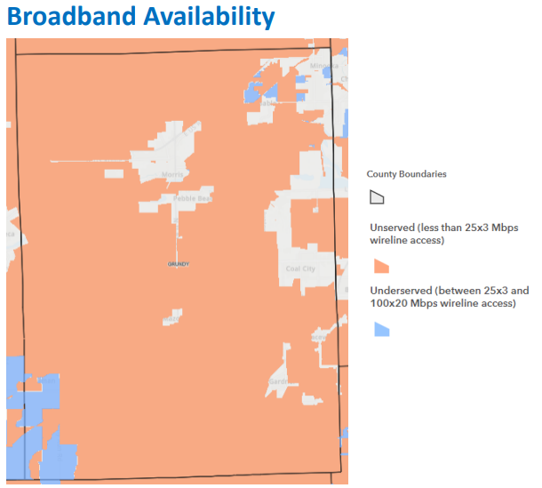

Figure 4 - Broadband Availability (From the State Broadband Office)

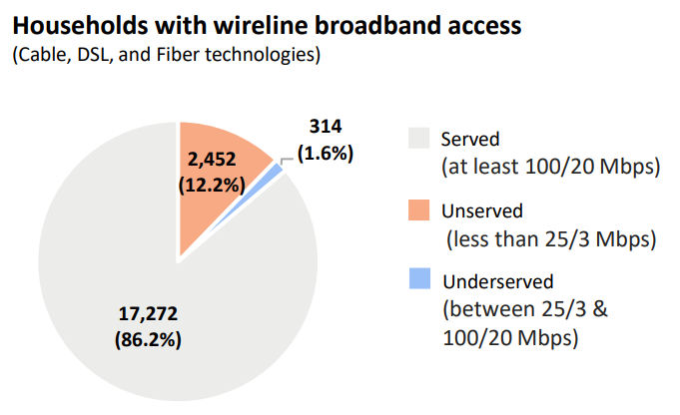
The chart below provides more insight into the information in Figure 1. With so much geography in orange in Figure 1, it is telling that only 12% of the addresses are in such a large area.

Figure 5 - Chart Showing The Rurality of Unserved

The map in Figure 6 is the FCC map for served, underserved and unserved areas in Grundy County. As is shown in the legend, there are areas in the southern parts of the County that are not served.

Served for broadband is defined as having 25 Mbps download speed from the internet and 3 Mbps upload speed to the internet.

The service described in this map are for “fixed broadband” which includes all fixed terrestrial technologies (fiber, cable, DSL, fixed wireless, etc.).

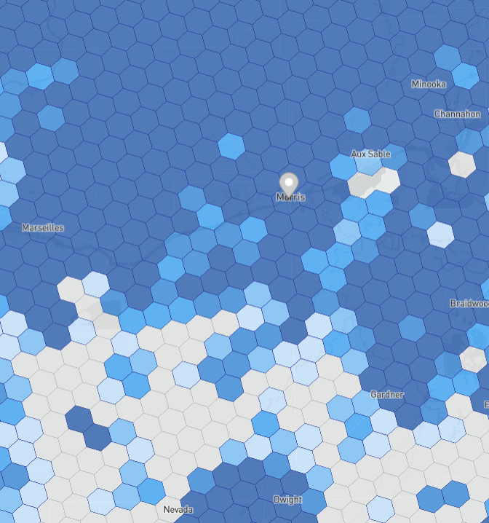

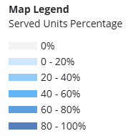

Figure 6 - FCC Map of Broadbnad Service Levels

Stakeholder interviews
From August 2025 to September 2025, stakeholder engagement meetings took place with anchor institutions, businesses, education, emergency medical services (EMS) / hospitals, libraries, municipal leaders, and regional leaders. The various goals of these meetings included identifying existing broadband needs, evaluating current broadband services, exploring future broadband expectations, and collaborating with county entities.
The initial step in the process was to identify key stakeholders. Once completed, virtual stakeholder one-on-one and group meetings took place with policymakers, anchor institutions, and key inﬂuencers to drive visibility into goals of the service area’s communities and to identify how best to position and future-proof Grundy County to maximize economic development, including retaining current residents and businesses, as well as attracting new residents and businesses to the area These meetings also explored the impacts of current and potential future broadband services on economic development for the municipalities within the County.
Goals for these meetings include:
- Gathering input from staff not just on governmental operations, but also on needs for public-facing Wi-Fi, commercial broadband services, residential broadband services, and communications support for emerging technologies.

Stakeholders
Engagement meetings were held with the following stakeholders or stakeholder groups:

Municipal Leadership
- Village of Channahon
  - Assistant Village Administrator
- Village of Mazon
  - Mayor
- City of Morris
  - Mayor

Anchor Institutions

Community Foundation of Grundy County
- United Way of Grundy County
- YMCA

Businesses
- Cloud Nine Web Design, LLC
- Simple Communications

Education
- Coal City Community School District #1
- Gardner – S Wilmington School District
- Grundy Area Vocational Center
- Joliet Junior College Morris Education Center
- Mazon-Verona-Kinsman School District
- Morris Elementary School District

EMS & Medical
- 9-1-1 Center
- Morris Hospital

Libraries
- Coal City Library District
- Morris Library

Regional Leadership
- County Highway

Key Findings
Below is a summary of key findings that were shared during the stakeholder engagement process.
- The majority of stakeholders reported being generally satisfied with their broadband services, with most individuals experiencing few outages and reliable, stable service.
- In select areas of the County, including portions of Morris and Coal City, some stakeholders mentioned how there appears to be limited viable Internet Service Providers (ISPs). This lack of competition is a concern for redundancy and service flexibility for an organization.
- One user mentioned that the high cost of switching providers or the build out of infrastructure is a barrier to improving or diversifying their broadband services.
- There are parts of the County experiencing poor cellular service, with unreliable connection indoors. From a school standpoint, this is a huge safety concern from the parents as they are worried that they can’t reach their children at school.
- The majority of stakeholders did not report having redundant broadband services, either with their primary or a secondary ISP. In addition, one stakeholder mentioned insufficient mobile wireless backup services which could not meet their workflow needs and requirements.
- Most stakeholders reported that outages were infrequent and typically weather-related. However, those located in remote or rural areas experienced longer outage durations.
- A majority of stakeholders rated broadband reliability as 4 or 5 out of 5, noting that service interruptions were generally brief and promptly resolved by their ISP.
- Lower reliability ratings were typically associated with remote or rural areas, where service is more inconsistent, resulting in more frequent outages and extended recovery times.
- Feedback indicated that in rural areas, stakeholders often experienced inconsistent support and delayed service restoration, highlighting a service disparity in less-served regions.
- The following ISPs were most frequently mentioned by stakeholders, in order of occurrence: Comcast, Illinois Century Network (which uses AT&T or Comcast), AT&T, Simple Communications, Surf, Coeo Solutions, and Mediacom.
- Among stakeholders who shared their actual internet service speeds, reported download speeds ranged from 50 Mbps to 10 Gbps, and upload speeds ranged from 20 Mbps to 10 Gbps.
- Within the ranges above, 6 out of 10 respondents reported download speeds below 1 Gbps. Additionally, 3 out of 6 respondents had upload speeds below 1 Gbps.
- Internet service costs, whether bundled or standalone, ranged from $0 to $1,970.28 per month. Of the 9 stakeholders who disclosed costs, 5 reported paying under $500 per month.
- Contract durations varied widely, from pay-as-you-go plans with no expiration to agreements extending through 2030. The majority of contracts were signed for a three-year term.
- Of the 7 schools and libraries surveyed, 5 confirmed participation in the E-Rate program to subsidize broadband access for students.
- Several municipalities noted that community feedback frequently emphasized the need for improved rural broadband coverage and concerns about the high cost of service.
- Many stakeholders highlighted persistent broadband limitations in rural and southern parts of the County, especially areas south of the Illinois River and outside municipal boundaries. Specific problem areas included Deer Lake Subdivision, Goose Lake, Seneca, and Graceville.
- Feedback was mixed regarding the adequacy and volume of ISP options in the Morris area. Some stakeholders felt broadband service was acceptable, while others expressed ongoing frustrations.
- Comcast was consistently identified as the dominant provider in the region, raising concerns about limited competition and elevated prices—particularly affecting student access.
- Stakeholders expressed a strong desire for increased ISP options to promote competition, reduce costs, and enhance service quality.
- Although some areas had multiple ISPs, stakeholders noted that service quality and reliability varied significantly between providers.
- Educational stakeholders unanimously agreed that without improved broadband access, student academic performance would suffer due to the increasing reliance on technology in education.
- Looking ahead five years, most stakeholders anticipated needing faster speeds and greater bandwidth. Some also emphasized the need for additional providers and improved cellular coverage in line with evolving organizational technology needs.
- Current County road Rights-of-Way (ROW) are limited to the roadway itself and do not include provisions for utility extensions. Routine road work, such as repaving, typically does not require the County Highway Department to purchase additional ROW. However, when road expansion projects do require new right-of-way acquisitions, the County has adopted a policy in recent years to include utility extensions as part of the acquisition and contract process.
- When asked about an ideal broadband program, stakeholders emphasized the importance of County-wide access, particularly in underserved rural and southern areas. Equitable, affordable access, including tiered pricing or low-cost options, was identified as a critical priority.
- An ideal broadband program would deliver fast, reliable, and consistent service to support remote work, telehealth, education, and other digital activities. Stakeholders also stressed the need for resilient and redundant infrastructure, especially for business and emergency services, supported by a long-term, strategic vision.
- Stakeholders also identified the need for more providers to foster healthy market competition, reduce prices, improve service quality, and enable infrastructure diversification.
- When asked about potential assistance from Grundy County in collaboration with private sector partners, stakeholder interest varied. Most were open to learning more, though some raised concerns about service reliability, agreement terms, funding consistency, and potential conflicts with existing infrastructure or provider relationships. Those not interested in County assistance were generally satisfied with their current ISPs and reluctant to switch unless their current service drastically changed.
- In response to the previous question, several organizations offered support: the Grundy Area Vocational Center volunteered its Technology Director to assist in any capacity; Coal City Unit School District #1 expressed willingness to support the initiative; and Morris Hospital indicated interest in helping determine network routing and infrastructure placement.
- Stakeholders suggested that as municipalities determine which ISPs will serve their areas, it would be beneficial for the County to engage those providers to discuss potential expansion opportunities within Grundy County.
The table below includes a summary of key findings broken out by the stakeholder groups that were part of the engagement process.
Stakeholder Group | Key Findings
Village of Channahon | - Working with multiple ISPs to overbuild the whole Village.  - Benefits of improving broadband access would result in redundancy for government facilities and lower cost, which are current concerns for the Village.  - They wish to expand their first responder ISP coverage.
Village of Mazon | - Recently switched over to a different ISP who is conducting a 50% buildout of a fiber network within the Village area.  - Five municipal facilities are all on fiber, including 4 buildings and the ambulance service, which utilizes the Village’s fiber.  - Mentioned how the newer parts of the Village have underground utilities, while the older parts have utilities hooked up on poles.  - Future broadband use revolves around the affordability of getting a security camera system up and running for them.
City of Morris | - The City has a dozen facilities reliant on a broadband connection, including water plants and a Public Works building.  - The airport is the only municipal facility which runs on a separate ISP, which sufficiently meets their broadband requirements.  - Current broadband usage is focused on security systems and remote water and sewer communication. Future needs depend on compliancy requests stemming from those beyond the City.  - The City’s ISP has been replacing cable with fiber.  - If broadband access was not continuously improved in the area, there would be an outcry of discontent throughout the community. However, at the moment there is no concern regarding service.
Community Foundation of Grundy County | - With a recently upgraded package from their provider, the Foundation was able to increase download/upload speeds to improve the situation.  - The organization has observed a growing trend among social services clients who rely primarily on mobile phones, rather than laptops, as their main means of accessing broadband and submitting required documentation.  - The organization's two buildings are each connected to the internet through a different ISP.
United Way of Grundy County | - Their contracted ISP implemented an update that significantly enhanced broadband service quality.  - Workflows involving everything from payroll & taxes to emailing & backups, are all heavily reliant on broadband usage.  - United’s ISP bill is annual negotiated for a bundle discount.
YMCA | - Each of their two buildings is served by a different ISP as this was cheaper due to associated build out costs based on the location.  - The YMCA encountered challenges with the ISP build-out at one of their buildings, resulting in project delays that extended the timeline by several months.  - Has two separate ISP conduits going into one of their buildings due to the ISPs refusing to share the space.
Cloud Nine Web Design, LLC | - The business was based out of Grundy County prior to moving office locations.  - Cloud Nine noted the potential presence of the untapped market with antiquated digital subscriber lines (DSL) in the area.  - All business workflows utilize broadband, with the one exception of Voice over Internet Protocol (VoIP) technology.
Simple Communications | - Most services provided by Simple are cloud hosted, with very few systems run in-house locally.  - Many of their clients have expressed interest in contracting a secondary ISP. However, limited availability makes this option unfeasible.  - Looking into the future, they will need faster fiber to keep up with client demands and technology needs.
Coal City Community School District #1 | - During COVID, the District offered 10 students experiencing connectivity issues by checking out hotspots.  - Current technology trends include utilizing Artificial Intelligence (AI), video production at the high school, and online resources for interventions and day-to-day resources.  - The District transitioned to a different internet service provider; however, both the previous and current providers have proven to be reliable and have consistently met the District’s needs
Gardner – S Wilmington School District | - School District relies on broadband connectivity to the high school and the K-8 grade school.  - Each student is provided with a Chromebook and only one student requested a hotspot to boost broadband due to connectivity issues.  - The District periodically replaces their infrastructure to update them as needed. They acknowledged how infrastructure is the hardest part for upkeep as it is the most expensive component.  - During COVID, the District offered parents and children Wi-Fi in the school parking lot, but no one took them up on that offer.
Grundy Area Vocational Center | - The Center serves as a tech campus for junior and senior high school students is located on the Morris High School campus.  - They offer a computer graphics class which relies on heavy broadband usage. However, they have not received complaints from students about lagging and insufficient speeds.  - The Center invests $40,000 - $50,000 yearly into technology to stay current with the industry.
Joliet Junior College Morris Education Center | - During COVID, they offered wireless access points free of charge and devices with cellular data for students experiencing problems accessing broadband to complete their schoolwork.  - The Center predominantly focuses on helping students enroll in classes and provide training to improve chances for successful employment. As such, this is a satellite site without many students on campus.  - Currently this site is sharing a leased space with another organization but may eventually move to a stand-alone building to help better meet the needs of the local community.
Mazon – Verona – Kinsman School District | - They recently switched over to a different provider, but both the previous and the current provider met the needs of the District.  - During COVID, the District had 95% of their students in the building. In 2020, they provided paper packets to students if they had connectivity issues, but no issues were brought up.  - Emphasized the need for reliable speeds as a lot of the District’s research-based interventions and curriculum platforms are online.
Morris Elementary School District | - 4th grade and higher students use Chromebooks continuously throughout the school day.  - The Chromebooks have been functioning well for the students as the school’s broadband connection is fairly reliable.  - During COVID, the District deployed 30 hotspots to families who didn’t have the broadband access necessary for schoolwork.
9-1-1 Center | - They utilize their own infrastructure to distribute broadband connectivity to the five additional tower sites associated with the Center.  - Current broadband requirements focus on processing a large volume of videos from various organizations, which must be accessible to law enforcement and the Center’s call takers.  - The backup connection for the Center’s towers and facilities is provided through the County’s ISP via licensed microwave links.
Morris Hospital | - Morris Hospital is the only hospital in Grundy County and they were (and may still be) the largest employer in the County.  - They require a lot of redundancy as an organization for their network of about 25 to 30 locations/site surrounding the hospital.  - Due to the Hospital’s internal configuration, their availability is up to 99.85, or greater.  - The Hospital receives federal funding from Universal Service Administrative Company (USAC) to help reduce the cost of wide area connectivity for their various locations/sites.  - Telemedicine, telepsychiatry, teleradiology, and patient portal services rely on broadband usage. Future broadband use involves expanding telemedicine services, pre-arrival technology, and improved physician abilities to do telework.
Coal City Library District | - The District offers 60 hotspots for patrons to check out as a way to bridge connectivity issues at home.  - Major demand for these hotspots occurs during the summertime.  - They provide hotspots for recitals at the local high school to allow staff the ability to run credit card transactions.  - The District owns their own fiber line between their two buildings.  - The District used to turn off their WiFi at night, but have since changed that as students needed it for their schoolwork  - Since COVID, computer usage has gone up at the libraries.
County Highway | - Clarified that, in the County, adjacent landowners typically own property up to the centerline of the road. The County Highway occupies this area exclusively for road-related purposes, such as construction and improvement.  - Any utility seeking access to the County easement must obtain approval from the landowner for any work within the County ROW, unless the area is part of a platted subdivision or the County holds title to the ROW.

Gap Analysis Appendix of Questionaires

Grundy County Broadband Planning
Anchor Institution & Business Questionnaire

Your Organization Name:
Your Name:
Introduction:
HR Green is currently working with Grundy County to provide a broadband framework and structural model that improves internet connectivity and access in the County. Grundy County is very interested in understanding your current services, your level of satisfaction and your overall interest in innovative ways to provide improved broadband to the County.

The questions below will help you prepare for our upcoming meeting, and we encourage you to complete this form and bring it to the virtual session.

Questions:
- How well served is your organization with your current broadband services? Please explain why.
  - Have you noticed any visible gaps in your service? If so, what are they?
- On a scale of 1 to 5 (with 1 being poor and 5 being excellent), how would you rate your service for reliability and problem resolution?
  - How frequently do users experience outages on your current platform?
  - What has been the impact of those outages?
- Do you own your own network (including infrastructure) or do you lease services from an internet service provider to connect and carry your internet traffic?
- Who is your current internet provider?
  - What is your actual level of service in megabits or gigabits per second?
  - What is your monthly cost of service for internet access?
  - Are any ISPs providing redundancy?
  - When does your current contract expire?
  - What is the duration of the contract (i.e. 1-year, 2-years)?
- Do you think there are enough desirable alternatives to meet the needs of residents and businesses throughout the region? Why or why not?
- Do you know of any locations in the County with problematic broadband connection?
- If Grundy County were to enlist the private sector and provide some sort of assistance to help improve your organization’s internet services, would you be interested in participating?
  - What reservations would prevent you from saying yes?
- What are the current trends in technology used by your organization that are reliant on a broadband connection?
  - Looking forward, in five years, what types of broadband service do you expect you will need to effectively meet your organization’s needs?
- In your opinion, what would an ideal broadband program look like for the region?
- If applicable, do you know of any exclusivity agreements your organization has with an ISP for any of your properties?

Grundy County Broadband Planning
Education Questionnaire
Your Organization Name:
Your Name:
Introduction:
HR Green is currently working with Grundy County to provide a broadband framework and structural model that improves internet connectivity and access in the County. Grundy County is very interested in understanding your current services, your level of satisfaction and your overall interest in innovative ways to provide improved broadband to the County.

The questions below will help you prepare for our upcoming meeting, and we encourage you to complete this form and bring it to the virtual session.

Questions:
- How well served is your organization with your current broadband services? Please explain why.
  - Have you noticed any visible gaps in your service? If so, what are they?
- On a scale of 1 to 5 (with 1 being poor and 5 being excellent), how would you rate your service for reliability and problem resolution?
  - How frequently do users experience outages on your current platform?
  - What has been the impact of those outages?
- Do you own your own network (including infrastructure) or do you lease services from an internet service provider to connect and carry your internet traffic?
- Who is your current internet provider?
  - What is your actual level of service in megabits or gigabits per second?
  - What is your monthly cost of service for internet access?
  - Are any ISPs providing redundancy?
  - When does your current contract expire?
  - What is the duration of the contract (i.e. 1-year, 2-years)?
- Do you currently participate in E-Rate or other state/federal funding to pay for services? If so, which programs are you utilizing and are you participating in a leased model, or do you own your infrastructure?
- What has been the general feedback you’ve heard from students/parents regarding their broadband services?
- Do you know of any locations in the County with problematic broadband connection?
- Do you think there are enough desirable alternatives to meet the needs of residents and businesses throughout the region? Why or why not?
- How did your school adapt to providing broadband to students during COVID?
- If Grundy County were to enlist the private sector and provide some sort of assistance to help improve your organization’s internet services, would you be interested in participating?
  - What reservations would prevent you from saying yes?
- What are the current trends in technology used by your students and staff that are reliant on a broadband connection?
  - Looking forward, in five years, what types of broadband service do you expect you will need to effectively meet your organization’s needs?
- What do you think are the risks of not improving access to broadband for your students (aka, doing nothing)?
- In your opinion, what would an ideal broadband program look like for the region?

Grundy County Broadband Planning
EMS & MEdical Questionnaire
Your Organization Name:
Your Name:
Introduction:
HR Green is currently working with Grundy County to provide a broadband framework and structural model that improves internet connectivity and access in the County. Grundy County is very interested in understanding your current services, your level of satisfaction and your overall interest in innovative ways to provide improved broadband to the County.
The questions below will help you prepare for our upcoming meeting, and we encourage you to complete this form and bring it to the virtual session.
Questions:
- How well served is your organization with your current broadband services? Please explain why.
  - Have you noticed any visible gaps in your service? If so, what are they?
- On a scale of 1 to 5 (with 1 being poor and 5 being excellent), how would you rate your service for reliability and problem resolution?
  - How frequently do users experience outages on your current platform?
  - What has been the impact of those outages?
- How many of your facilities require broadband connection?
- Who is your current internet provider?
  - What is your actual level of service in megabits or gigabits per second?
  - What is your monthly cost of service for internet access?
  - Are any ISPs providing redundancy?
  - When does your current contract expire?
  - What is the duration of the contract (i.e. 1-year, 2-years)?
- Do you think there are enough desirable alternatives to meet the needs of residents and businesses throughout the region? Why or why not?
- Do you currently participate in any federal funding or state grant programs (such as the Healthcare Connect Program) funding to pay for services? If so, are you participating in a leased model, or do you own your infrastructure?
- Do you know of any locations in the County with problematic broadband connection?
- If Grundy County were to enlist the private sector and provide some sort of assistance to help improve your organization’s internet services, would you be interested in participating?
  - What reservations would prevent you from saying yes?
- What are the current trends in technology used by your organization that are reliant on a broadband connection?
  - Is your organization and community researching telemedicine?
- Looking forward, in five years, what types of broadband service do you expect you will need to effectively meet your organization’s needs?
- In your opinion, what would an ideal broadband program look like for the region?

Grundy County Broadband Planning
Library Questionnaire
Your Organization Name:
Your Name:
Introduction:
HR Green is currently working with Grundy County to provide a broadband framework and structural model that improves internet connectivity and access in the County. Grundy County is very interested in understanding your current services, your level of satisfaction and your overall interest in innovative ways to provide improved broadband to the County.
The questions below will help you prepare for our upcoming meeting, and we encourage you to complete this form and bring it to the virtual session.
Questions:
- How well served is your organization with your current broadband services? Please explain why.
  - Have you noticed any visible gaps in your service? If so, what are they?
- On a scale of 1 to 5 (with 1 being poor and 5 being excellent), how would you rate your service for reliability and problem resolution?
  - How frequently do users experience outages on your current platform?
  - What has been the impact of those outages?
- Do you own your own network (including infrastructure) or do you lease services from an internet service provider to connect and carry your internet traffic?
- Who is your current internet provider?
  - What is your actual level of service in megabits or gigabits per second?
  - What is your monthly cost of service for internet access?
  - Are any ISPs providing redundancy?
  - When does your current contract expire?
  - What is the duration of the contract (i.e. 1-year, 2-years)?
- Do you think there are enough desirable alternatives to meet the needs of residents and businesses throughout the region? Why or why not?
- Do you currently participate in any federal funding or state grant programs (such as E-Rate) funding to pay for services? If so, are you participating in a leased model, or do you own your infrastructure?
- What has been the general feedback you’ve heard from constituents regarding their broadband services?
- Do you know of any locations in the County with problematic broadband connection?
- If Grundy County were to enlist the private sector and provide some sort of assistance to help improve your organization’s internet services, would you be interested in participating?
  - What reservations would prevent you from saying yes?
- What are the current trends in technology used by your organization that are reliant on a broadband connection? Looking forward, in five years, what types of broadband service do you expect you will need to effectively meet your organization’s needs?
- In your opinion, what would an ideal broadband program look like for the region?
Grundy County Broadband Planning
Municipal Leadership Questionnaire
Your Organization Name:
Your Name:
Introduction:
HR Green is currently working with Grundy County to provide a broadband framework and structural model that improves internet connectivity and access in the County. Grundy County is very interested in understanding your current services, your level of satisfaction and your overall interest in innovative ways to provide improved broadband to the County.
The questions below will help you prepare for our upcoming meeting, and we encourage you to complete this form and bring it to the virtual session.
Questions:
- How well served is your organization with your current broadband services? Please explain why.
  - Have you noticed any visible gaps in your service? If so, what are they?
- On a scale of 1 to 5 (with 1 being poor and 5 being excellent), how would you rate your service for reliability and problem resolution?
  - How frequently do users experience outages on your current platform?
  - What has been the impact of those outages?
- Do you own your own network (including infrastructure) or do you lease services from an internet service provider to connect and carry your internet traffic?
- Who is your current internet provider?
  - What is your actual level of service in megabits or gigabits per second?
  - What is your monthly cost of service for internet access?
  - Are any ISPs providing redundancy?
  - When does your current contract expire?
  - What is the duration of the contract (i.e. 1-year, 2-years)?
- Do you think there are enough desirable alternatives to meet the needs of residents and businesses throughout the region? Why or why not?
- Do you know of any locations in the County with problematic broadband connection?
- What has been the general feedback you’ve heard from constituents regarding their broadband services?
- If Grundy County were to enlist the private sector and provide some sort of assistance to help improve your organization’s internet services, would you be interested in participating?
  - What reservations would prevent you from saying yes?
- What are the current trends in technology used by your organization that are reliant on a broadband connection? Looking forward, in five years, what types of broadband service do you expect you will need to effectively meet your organization’s needs?
- What do you think are the benefits of improving access to broadband for your municipality?
- What do you think are the risks of not improving access to broadband for your municipality (aka, doing nothing)?
- In your opinion, what would an ideal broadband program look like for the region?

Grundy County Broadband Planning
Regional Leadership Questionnaire
Your Organization Name:
Your Name:
Introduction:
HR Green is currently working with Grundy County to provide a broadband framework and structural model that improves internet connectivity and access in the County. Grundy County is very interested in understanding your current services, your level of satisfaction and your overall interest in innovative ways to provide improved broadband to the County.
The questions below will help you prepare for our upcoming meeting, and we encourage you to complete this form and bring it to the virtual session.
Questions:
- How well served is your organization with your current broadband services? Please explain why.
  - Have you noticed any visible gaps in your service? If so, what are they?
- On a scale of 1 to 5 (with 1 being poor and 5 being excellent), how would you rate your service for reliability and problem resolution?
  - How frequently do users experience outages on your current platform?
  - What has been the impact of those outages?
- Do you own your own network (including infrastructure) or do you lease services from an internet service provider to connect and carry your internet traffic?
- Who is your current internet provider?
  - What is your actual level of service in megabits or gigabits per second?
  - What is your monthly cost of service for internet access?
  - Are any ISPs providing redundancy?
  - When does your current contract expire?
  - What is the duration of the contract (i.e. 1-year, 2-years)?
- Do you know of any locations in the County with problematic broadband connection?
- How well do you feel the region is served today with broadband services? Please explain why.
- Do you think there are enough desirable alternatives to meet the needs of residents and businesses throughout the region? Why or why not?
- What are the current trends in technology used by your organization and the region that are reliant on a broadband connection? Looking forward, in five years, what types of broadband service do you expect you will need to effectively meet your organization’s needs?
- What are your thoughts about Grundy County potentially exploring broadband solutions for the residents and/or the businesses in the County?
- If Grundy County were to enlist the private sector and provide some sort of assistance to help improve your organization’s internet services, would you be interested in participating?
  - What reservations would prevent you from saying yes?
- Do you think that your department/organization would be able to leverage existing systems/programs/staff to help provide broadband services? Why or why not?
- In your opinion, what would an ideal broadband program look like for the region?

Visioning Session
The Gap Analysis brings the data together to be studied to more clearly define the strengths and weaknesses of broadband in the County. Once that information is assimilated, it is important to pause and digest what the data shows and to develop a strategy to address the broadband challenges. HR Green refers to this step as the Visioning Session.

The meeting for visioning was held virtually on September 29, 2025 at 2:00. In attendance were: Nancy Norton (Grundy County Economic Development), Aindrea Hogan (Grundy County Economic Development), Christina van Buren (Grundy County Chamber of Commerce), Alec Macdonald (Grundy County Director of Development), Dave Ostrander (Grundy County GIS Director), Georgette Vota (Grundy County Board), Eric Gibson (Grundy County Engineer), Kevin Lindeman (NCHGC).

The meeting agenda for the Visioning Session was:
- Review the Gap Analysis
- Present and discuss the findings detail
- Resources
- Next steps

The following details were discussed:
- Gap Analysis:
  - ROW – property owners own to the centerline of the road in many parts of the County. This is a challenge for ISPs because they have to get an easement from every property owner along the path they desire to build and it only takes one property owner who either does not want a utility put on his/her land or wants an exorbitant amount of money to stop an entire project
  - Previous build issues: In the recent past, ISPs were deploying fiber, but there were parts of the project that did not go well. The processes seem to have been corrected, and the work has been remediated. The potential lingering Issue could be if an ISP needs an easement permit, the property owner may be less likely to allow this to happen because of concerns regarding the problems others have faced
- Findings Detail
  - The FCC data points out that there are unserved areas in the southern portion of the County
  - After the Visioning Session, HR Green was able to connect with the Morris library. Their staff indicated that there are broadband issues in the Southwest part of the County. They discussed three indications they have of broadband challenges. The first is the computers they have in the library are almost always taken. The second is they have a mobile hotspot checkout program and there is often a waiting list to get them. Details on their hotspot program can be found at: https://morrislibrary.com/hotspots/#:~:text=Mobile%20WiFi%20hotspots%20are%20small,if%20you%20have%20any%20questions.
The third indication regarding broadband challenges they observe in their area is they have people who request technical help with broadband. They discussed seeing that there are quite a few people who have very slow and low-capacity internet. It is not clear if those people do not realize what they do not have or if they just make due
- Gap Analysis – Resources
  - There are available ISPs to work with. These are listed in the Market Assessment section of this report, but there are ISPs in the County and in the area to continue working with
  - Grants are coming through Connect Illinois – BEAD application and future grants will be available
  - Dig Once policies are a suggestion for the County to implement
  - ClearSky is going over the ComEd network – this prevents ClearSky having to get individual easements (it appears they only need to get easements for where they connect onto the pole)
    - Any ISP which wants to use ComEd’s poles can, but it’s on a first come first serve basis
    - ComEd is working on a digital map which will be available to agencies who sign an NDA to show ComEd network availability
  - Utilities in the area – Wind Farm assets. It appears the wind farm assets include telecommunications assets. There may not be excess capacity (conduit or fiber), but if there is and the companies are willing to share, this could be a significant resource to improve broadband (existing infrastructure that would likely not need additional easements
- Vision: There are broadband challenges in Grundy County both in having adequate infrastructure to have good broadband available and in having a communications network that is resilient in the case of problems in the County and that will facilitate further economic growth. There are also solid resources to help address the broadband services and resiliency concerns over time. The building blocks need to be put in place to facilitate and coordinate broadband improvements over several years.
- Next Steps
  - Having a GIS map that shows the roads in the area that has broadband challenges. As solutions are put in place (ComEd, ISPs, grants, County Highway purchasing ROW, other utility infrastructure that has connectivity (wind, solar and other utilities)), those road segments can be marked on the map, leaving the road segments that still need to be addressed. This process can help coordinate resources to continue to resolve issues
  - Regular discussions with ISPs for their next steps, can they piece together solutions that cover the broadband challenges
  - Grants: There are grants available both now and will very likely be in the future – monitoring who wins any awards in Grundy County or in close proximity will be important to see if there are ways to work with them to expand networks from their grant awards
  - ROW: working with County Highway, the Townships, ComEd’s available network, etc.
    - The County Highway is able to grant permissions to utilities
      - Township road staff are not buying ROW – they only maintain the roadways (the majority are just doing surface repairs. They may just purchase ROW for culverts and near bridges but that’s the extent
      - The townships maintain roughly 130 miles of road
      - Board Member Vota mentioned she has not heard much about broadband issues
        - When asked if farmers have issues with connectivity for their equipment, she said she has not heard of any, but she will reach out to farmers and ask them
        - She had personal experience with trying to get connectivity in Coal City for a club, but it involved fixed wireless solutions
    - Mr. Macdonald brought up the question of why not include other technology types instead of fiber. Other technologies do have their place and can be better than no solutions. However, fiber is the most resilient technology and is the preferred (but not the only) route - all will be considered
  - Ensuring broadband related policies help improve broadband

Options to Improve Broadband – High-Level Design
The high-level design (HLD) is a key deliverable that serves multiple purposes in the Grundy County Broadband Analysis and Feasibility Study:
- Map: One of the recommendations in the Executive Summary is, “Utilize The High-Level Design (HLD) Map”. The below is the referenced map. It is also provided to the County in GIS format. This map is intended to be used to better understand costs for broadband improvements, to track and coordinate steps that are taken, to strategize next steps for road segments that do not have an improvement plan, to coordinate with ISPs, etc. As steps are taken (like adding conduit, determining that ComEd has available middle mile fiber, an ISP adds network on a segment, etc.), the color of that segment can be changed accordingly, showing what is left to be done and to be used to plan subsequent improvements
- Costing information: Understanding costs is important in planning potential improvements, in discussions with ISPs and in requesting grants. Cost are listed in two ways to help in calculating road segments. Cost per passing (see the Glossary in Appendix A) and Cost Per Foot. These numbers can be used to determine the cost of a road segment when options for improving broadband are being considered
- Tool for discussions with ISPs: This map can help in discussions with ISPs in several ways. The addresses can help ISPs visualize the sales opportunities. Having HLD costing can also help in discussions to have a better feel of what they are facing in extending their networks. The maps and costs can also help in discussions regarding possible grants. As information is filled in (like ComEd fiber, conduit that is installed, ROW that is available), these types of data are significant to ISPs in helping them decide to build in Grundy County
- Middle Mile: These maps do not show middle mile (see Glossary) yet. However, as conduit is installed (for example, with dig once policies), as available ComEd fiber is shown, etc., ISPs can see how they can connect to the internet and potentially lower their build costs. This can be an important incentive to ISPs
- Grants: Having preliminary design and costs can help in formulating grant applications

It is important to note the designs and costs are high-level based on costs in projects in the area. Final design and final costs will need to be determined by the entity planning construction. The costs can vary for many reasons, for example how road segments for specific projects are determined, construction costs at the time (costs are currently volatile), how close middle mile is, etc. However, these numbers are a good starting point.

The entity that builds the network will need to plan for other CapEx and OpEx costs. For example, all networks need to have Network Access Equipment. This is the equipment on the ends of the fiber that are necessary for the network to function. The fiber transports the data, the Network Access Equipment operates the network and sends the data over the fiber. If the entity building and owning the network does not have operating equipment, then that will be an added expense (which could include the space to house it.

ISPs often already have their main equipment, so they would likely not have to add that to their costs. Drops will also need to be added into the costs and they can be a significant part of the total costs. If middle mile is not fairly close, that can be a measurable expense. Also, the ongoing operations and maintenance of the network can be significant expenses. If an existing ISP builds or extends their network, they often already have the people to perform operations in place.

If the County decides to build a functioning network or ring, they could figure in these additional costs and could operate and maintain the network or contract out these functions. In the report section “ISP Relationships and Partnership Opportunities” there is a more thorough discussion of the models within which networks can be built and operated in conjunction with partners.

There is an important distinction between building a network, a ring and conduit:
- A network typically connects end users like residents, businesses and/or anchor institutions. These require equipment and ongoing operations. As mentioned previously, ongoing operations and maintenance can be contracted out
- A ring typically connects public facilities. These usually require far less equipment and operations and are most often less expensive to build because they do not include as many drops. They also do not enter the competitive realm because they are for government or anchor institution use only
- Conduit is an open tube that is installed that fiber can be put into later. As part of dig once policies, it is recommended that conduit be installed whenever possible during other construction projects (like roads and other utilities). This conduit needs to be documented (so that it is known what is available later). There is not operation because it is not a network, it is available to lower costs of network builds. If the County installs conduit during other projects, it can be much less expensive to install. ISPs will be very interested in using it because it greatly reduces their cost. The County could then, lease it to them at a lower cost than it would take the ISPs to build (because the County was able to install it at a lower cost during other projects)

The following maps provide design and network cost information.

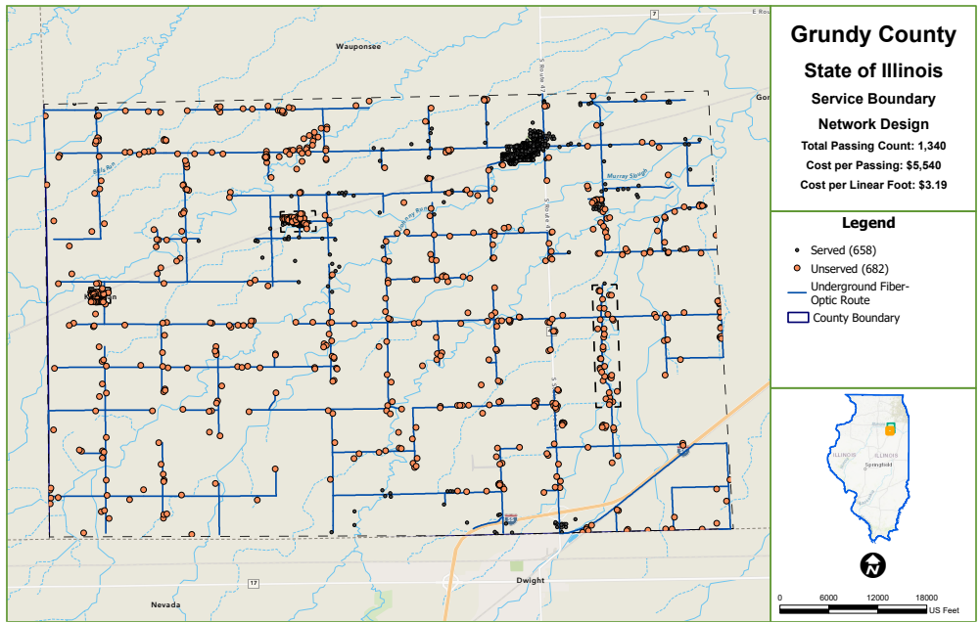

Figure 7 - Overall Map Of SW Grundy County HLD Network

This map shows an entire network for all of the Southwest quadrant of Grund County. It includes addresses that are noted as served (the smaller circles) and addresses that are considered unserved and underserved. The unserved and underserved could be eligible for grants (unless they have already received a grant award).

The network designed in this HLD is all underground (not on poles like ComEd) and a typical fiber designed network. Notice in the legend that there are 1,340 passings (addresses) and the cost per passing that HR Green calculated is $5,540. Therefore, the cost for just the basic fiber network would be approximately $7.5M.

The costs that would need to be added to that would be significant components like drops, which would vary but could be as much as $2M - $3M or more (in rural settings, the fiber needed to go from the network fiber to the address can be long distances (which can increase costs dramatically).

It is also typical to add approximately 20% contingency. Therefore, a total build could be in the $12M – $15M range before access equipment, operations and dept burden.

The key in understanding these numbers for an ISP is thinking in terms of Return On Investment (ROI). With the number of potential customers that is reasonable, the question is how long it will take them to be cash-positive and to recoup their investment. In rural areas, that can be challenging math. That is why grants and using much less expensive conduit are so important in the math equation. Those can lower the costs significantly, which makes their investment much more attractive.

As a frame of reference, HR Green produced some HLDs of subset areas of the overview network above. This map shows the Kinsman area. This is included in the overview map but broken out for illustrative purposes.

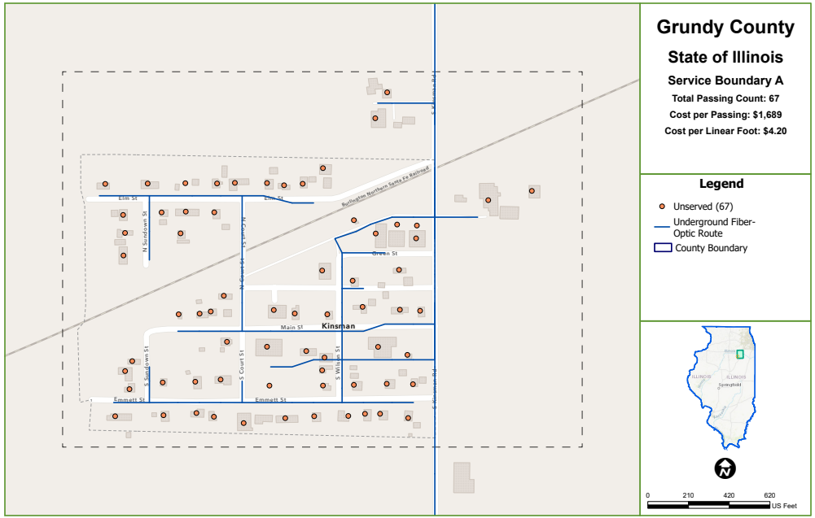

Figure 8 - Service Boundary A (Subsection of Overview Map)

According to the legend, there are 67 addresses in this area. Notice the cost per passing is far less than the total in the overview map ($1,689 verses $5,540 per passing). The reason for the difference is the addresses are much closer together. However, there are some details to point out in this map. First, there is a railroad that runs through this network. Railroads often add significant time to get to the build and can be very expensive to cross. This design shows two crossings. An ISP might choose to build on only one side or only have one crossing. Second, the location of middle mile will likely be very important. If it is not close, the fiber needed to get to it could be very expensive to install.

The next subsection is the Verona area:

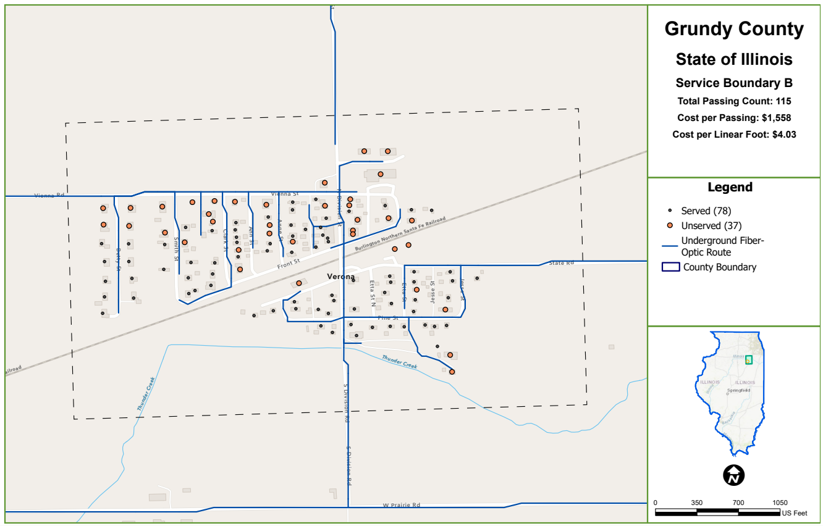

Figure 9 - Service Boundary B - Verona

Like Kinsman, the costs per passing are lower because of density. This design only crosses the railroad once. If middle mile is close, the cost per passing of this area is much closer to the costs an ISP looks for in an area to build.

The last subsection is along Old Mazon Road south of Highway 53:

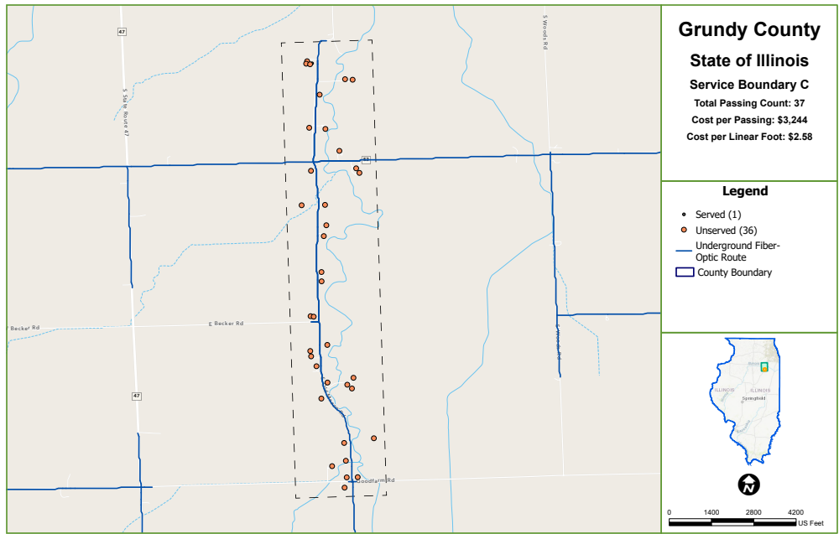

Figure 10 - Service Boundary C - Old Mazon Rd.

In this subsection, the costs begin to increase again because of lower density and the addresses being more spread out.

ISP Relationships and partnership opportunities
As discussed in the Market Assessment section of this report, there are several ISPs in Grundy County and the area. They could be a significant resource in broadband improvement.

Deciding how to partner with ISPs is an important decision. The following chart from the Brookings Institute shows the different options that Grundy County has in working with a private partner.

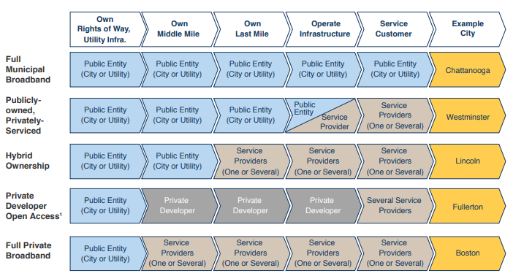

Discussions with the County to date indicate the County has a preference for a Full Private Broadband model. However, there are other models that could be employed.

Conduit ownership could take a somewhat different approach. The County could install conduit during other construction projects (road, utilities, etc.). Conduit placement can be significantly less expensive during other construction projects. Because of lower costs and an ability to consider a longer return on investment timeframe, the County could lease it to an ISP(s) for much lower than the ISP would pay to install it. In that scenario, the County could recoup the cost of conduit over time and provide a significant incentive for an ISP to invest in broadband improvement in the County.

The Market Assessment lists the current potential ISP partners in and around Grundy County. As discussed in the Recommendations, having regular meetings with them to go through the information in this report and then to have regular discussions about updates and to explore options to improve broadband could be a significant step in coordinating broadband improvement.

Policy Review and Suggestion
In talking with ISPs, they did not bring up policies as being problematic in the County. They mainly discussed the challenges that come from many County roads not having ROW (property ownership to the center line of the road – requiring easements for each property.

HR Green did a high-level review of Grundy County policies regarding broadband. The policies related to broadband appear to be spread out throughout County policies. The major sections regarding broadband and telecommunications infrastructure appear to be:
- Title 4 Public Safety
- Title 8 Unified Development Code

Title 4 does reference telecommunications providers but appears to deal mainly with what they are required to remit to the County. Title 8 addresses development (project standards) in 8-6-3; financial guarantees in 8-6-4; project steps including closeout in 8-6-5; tree protection in 8-9-2; and permit processes in 8-14.

There do not appear to be policies that would likely prohibit an ISP from wanting to build in Grundy County. However, even though there do seem to be policies to address certain aspects telecommunications utility construction, it does not appear that there is a clearly defined section an ISP could go to for clear guidance on telecommunications infrastructure process, construction standards and guidelines. That does not appear to have hampered ISP interest, but it is possible those components could be used to attract broadband investment.

Therefore, HR Green recommends the following policy considerations:
- Master License Agreement (MLA): create an MLA template to be utilized to guide telecommunications infrastructure deployment. Because of Illinois State Law, telecommunications use of ROW is different than most other types of construction. An MLA is permissible under State Law and can be one document to guide the different aspects of telecommunications interactions (guidelines, approvals, connecting community facilities, fees, reimbursement of fees, etc.)
- Dig Once Policy: A dig once policy requires that any construction in the ROW (or possibly easements) be evaluated for the feasibility of installing broadband infrastructure (most commonly conduit) while the construction is being done. There are, typically, two components to a dig once policy:
  - The policy requiring the evaluation
  - The process for the evaluation. Basically, when a ROW related permit is being requested or any road or utility project is being planned, the process usually contains:
    - A notification to the County personnel who will initiate the review
    - An analysis is done to see if conduit could be placed
    - An evaluation of who would acquire and place the conduit (usually a contractor involved in the original project)
    - An estimate is completed for the cost of the conduit
    - A decision is made as to whether to proceed or not
    - If the conduit placement is moving forward, agreements are put in place
    - Coordination of the placement is handled through the project manager
    - As-built detail in GIS format so there is a good record of all conduit
To provide a context for the potential impact of dig once policies, if there would have been a dig once policy in place when the wind turbines went in (and conduit placement was feasible), there could be available conduit in the Southwest quadrant of the County. This would greatly reduce the costs for an ISP to deploy fiber, could provide a revenue stream from the conduit leasing and could alleviate the need for property-by-property easements
- GIS As Builts: Either in the MLA or in section 8-6-5 (project closeout) we recommend a requirement that broadband installation permittees be required to provide as-builts in GIS format. This will be good for future reference and it will help in updating the map that will coordinate future projects (see the Recommendations for the coordination GIS map based on HR Green’s HLD)

Appendix A – Glossary of Broadband Terms
Access – infrastructure that delivers broadband – if there is infrastructure available to a potential customer (through any technology), that potential customer has access.

Access Point – a device that allows wireless devices to communicate with a wired network using Wi-Fi or related standards. Sometimes referred to as AP, Wireless Access Point, or WAP. Access Points contain both a radio and a wired network connection, and relay communications between the two.

Adoption – customer decision to purchase broadband services that are available. Access describes that broadband connectivity is available – adoption describes whether a person chooses to subscribe to services. People may choose not to utilize available broadband services because they cannot afford it, language barriers, not understanding the technology, etc.

Backhaul: is the fiber that carries aggregated user data from the network’s central office to internet connection points located at carrier hotels.

Backbone/network backbone – in telecommunications, a generic term referring to the part of a network that interconnects all sites on the network, and, therefore, handles the majority of the network traffic. Smaller networks are attached to the backbone through aggregation sites by means of additional circuits and network devices, such as routers.

Bandwidth/high bandwidth – transmission capacity of an electronic pathway such as a communications circuit. Network bandwidth is described in terms of how much data can move across the network within a given amount of time and is typically expressed in bits per second (bps). Examples of measurements include kbps, Mbps or Gbps. The “high” in “high bandwidth” is always relative to current norms for different circumstances. High Bandwidth is a term that typically means a bandwidth at the top end or above what is commercially available at a given location.

Bits vs. Bytes – Bits are the measure of speed it takes the smallest unit of data to be carried across the internet. Bytes are the unit of measure of volume of data.

Broadband – a marketing term that refers to high bandwidth Internet access. Traditionally, it meant “any band- width greater than dial up.” Broadband data transmission is digital, meaning that text, images, and sound are all transmitted as “bits” of data. In the context of this project, Broadband refers to providing Internet connectivity at much higher bandwidth than has been available and affordable to most libraries. The FCC, in 2015, defines broadband to the home to be anything above 25 Mbps, in the sense that anything less than 25 Mbps to the home would not qualify as “broadband.”

Capacity/high capacity – is the complex measurement of the maximum amount of data that may be transferred between network locations over a network, also known as throughput. “High” is again relative to current norms and measured in bits per second (bps).

CapEx and OpEx costs – CapEx costs refer to the capital costs of building a network (the labor and materials needed to build the network). OpEx costs refers to all of the ongoing costs of operating the network (for example, the manager, customer service people, cost of the office, insurance, etc.).

CBRS – Citizens Broadband Radio Service – a wireless network capable of 4G and 5G connectivity that can be segmented to carry different applications (internet, Public Works related applications, public safety communications, etc.)

Co-location – refers to the way information technology hardware and resources are located or installed in a shared or common location. In this context, networking hardware resources owned by an organization are located outside the organization’s physical premises and “co-located” with other organizations’ hardware, often through a commercial service provider.

Commercial networks/carriers (provides) – any entity engaged in the business of providing telecommunications services that are regulated by the Federal Communications Commission or other governmental body. These are generally for-profit companies.

Cost per passing – see “Passing”

Digital Divide – According to the National Digital Inclusion Alliance (NDIA) the Digital Divide can be defined as: “…the gap between those who have affordable access, skills, and support to effectively engage online and those who do not. As technology constantly evolves, the digital divide prevents equal participation and opportunity in all parts of life, disproportionately affecting people of color, Indigenous peoples, households with low incomes, people with disabilities, people in rural areas, and older adults.” The NDIA refers to the Digital Divide as the problem, Digital Equity as the goal and Digital Inclusion as the Work.

Dark Fiber: installed fiber not currently being used.

Digital Equity – According to the NDIA Digital Equity can be defined as: “…a condition in which all individuals and communities have the information technology capacity needed for full participation in our society, democracy, and economy. Digital equity is necessary for civic and cultural participation, employment, lifelong learning, and access to essential services.” The NDIA refers to the Digital Divide as the problem, Digital Equity as the goal and Digital Inclusion as the Work.

Digital Inclusion – According to the NDIA, Digital Inclusion refers to: …the activities necessary to ensure that all individuals and communities, including the most disadvantaged, have access to and use of Information and Communication Technologies (ICTs). This includes five elements: 1. Affordable, robust broadband internet service; 2. Internet-enabled devices that meet the needs of the user; 3. Access to digital literacy training; 4. Quality technical support; and 5. Applications and online content designed to enable and encourage self-sufficiency, participation and collaboration. The NDIA refers to the Digital Divide as the problem, Digital Equity as the goal and Digital Inclusion as the Work.

Digital Subscriber Line (DSL) – a family of technologies that are used to provide Internet access by transmitting digital data over telephone lines. It may be either symmetric (same bandwidth both direction), or asymmetric (different bandwidth each direction). The service may be implemented simultaneously over the same lines used to provide voice service.

Drops – the extensions from the core network to each specific address. In a fiber network, the drops are, typically, fiber.

Federal Communications Commission (FCC) – the federal agency responsible for regulating interstate communications by radio, television, wire, satellite, and cable. The FCC also participates in international communications standards coordination and policy development.

FCC 477 – as part of the requirements to be a telecommunications utility, service providers are required to regularly submit specific information about the telecommunications services they provide. This information includes details like what census blocks within which they provide service, what speeds they offer, what technology they use, etc.

Fiber/fiber-optic cable – fiber optic technology converts electrical signals carrying data to light and transmits the light through transparent glass fibers. A variety of fiber optic cable types are available, depending on the application. Supported distances vary based on cable type, transmitter source (laser or
LED), data rate, etc.

Internet Service Provider (ISP) – a communications carrier that provides access to the Internet. ISPs are not necessarily directly connected via an Internet exchange; they may in turn acquire connectivity from another ISP.
Last mile connection – a term used by the telecommunications industry to refer to the final leg of a network to the customer, generally from the provider’s last POP to the customer.

Local Area Network (LAN) – a computer network that interconnects computers within a limited area such as a building or small group of adjacent buildings.

Long Term Evolution (LTE) – in telecommunication, a standard for wireless communication of high-speed data for mobile phones and data terminals.

Market Assessment – A review of FCC provider reported data. Private providers are required to report certain details of their coverage in FCC Form 477. The Market Assessment is an HR Green Report of Findings with analysis of the data directly from FCC and third party reporting organizations.

Megabits per second – see “Bandwidth” and “Throughput.”

Middle mile – at a high-level, networks are comprised of middle mile and last mile. Middle mile connects networks together and, ultimately, to the rest of the internet. Last mile extends from the middle mile to the customer.

Node - connection point that can receive, create, store, or send data along a network.

OpEx costs – see “CapEx and OpEx costs”.

Overbuild - to create a network that goes into competition with incumbent provider, often through building new fiber in an area that already has another technology.

Passing – A passing is an address (residence, business, anchor institution, etc. It is referred to as a passing in initial designs and costing because the full network is designed without any connections to those addresses. The full network is built without knowing which addresses will become customers – so the cost to go from the network to the address (called drops) are determined and built once a customer chooses to purchase services.

Point-to-Point – a microwave broadband application that requires line-of-sight from a transmission point to an end point. This technology is less expensive to install and can provide good service (depending on equipment and usage).

Population Density – population density will be classified as either urban, rural or remote. For the definition of eligibility for their grants and loans, Rural Utility Services defines rural in two ways: any area not within a city or town with population exceeding 20,000 or an urbanized area adjacent to a city greater than 50,000 and any area not within boundaries of any city, village, or borough with population exceeding 5,000. For this analysis, “rural” will mean either unincorporated or in a community less than 5,000. Remote will mean population density less than one person per twenty acres.

Right of Way – the land set aside for public passage or use (street, sidewalk, trail, utilities, etc.) which is owned or controlled by a governmental entity.

Terrestrial Broadband Infrastructure – broadband infrastructure that has equipment in or anchored to permanent structures – these can include fiber, cable, DSL and fixed wireless.

Throughput – rate of data transmission per unit time; see “Capacity/High Capacity”. The most common throughput measurements include:
- Kilobits per second (Kbps) – a transmission rate; 1,000 bits per second. 1,000 kbps = 1 Mbps. Kilo is the unit prefix for 103.
- Megabits per second (Mbps) – a data transmission rate; 1,000,000 bits per second. 1,000 Mbps = 1 Gbps. Mega is the unit prefix for 106.
- Gigabits per second (Gbps) – a data transmission rate; 1,000,000,000 bits per second. 1 Gbps = 1,000 Mbps or 1,000,000 kbps. Giga is the unit prefix for 109.

Unserved/Underserved – addresses that do not meet the FCC’s definition of having “broadband”. In 2024, the minimum threshold to be considered broadband was 25 Mbps downloaded from the internet and 3 Mbps in uploading to the internet. Going into 2025 those thresholds were increased to 100/10.

Wired or wireless infrastructure – wired infrastructure is infrastructure that has a physical wire or line run to the premise (fiber, cable or DSL). Wireless includes the technologies that do not have a physical line (point-to-point, radio frequency, etc.).

Wi-Fi (Wireless Fidelity) – a local area wireless technology that allows an electronic device to participate in computer network using specific wireless frequencies and protocols. Current standards use the 2.4 GHz and 5 GHz unlicensed industrial, scientific, and medical radio bands. Sometimes referred to as Wireless LAN or WLAN.

Comcast. “Timeline,” 2025. https://corporate.comcast.com/press/timeline
Xfinity. “Internet Availability,” 2025. https://www.xfinity.com/digital/offers/plan-builder
Comcast Business. “Check Availability,” 2025. https://business.comcast.com/shop/gateway
Frontier. “Why Frontier Communications,” 2025. https://agents.frontier.com/about-us#:~:text=Frontier%20is%20a%20Fortune%C2%AE,%2C%20TV%2C%20and%20phone%20services.
Frontier. “Frontier Internet,” 2025. https://go.frontier.com/internet
Frontier. “Frontier Business Fiber Internet,” 2025. https://go.frontier.com/business/fiber-internet
Hughes Network Systems, LLC. “Global Websites & Office Locations,” 2025. https://www.hughes.com/who-we-are/locations#north-america
HughesNet. “Satellite Internet Service from the Company that Invented It,” 2025. https://www.hughes.com/what-we-offer/satellite-internet
HughesNet. “Get Satellite Internet Service Now,” 2025. https://www.hughesnet.com/get-started#
Kraus. “High Speed Internet Services,” 2025. https://krausonline.com/kraus-internet-cable-phone-service-area/
Maxwire. “Fast-Reliable Wireless Internet Where You Live,” 2025. https://maxwire.net/
Xtream Powered by Mediacom. “Our History: Brief History of Mediacom,” 2025. https://mediacomcable.com/about/why-mediacom/
Xtream Powered by Mediacom. “Choose Your Plan,” 2025. https://shop.mediacomcable.com/offers
Mediacom Business. “Business Internet Plans,” 2025. https://mediacombusiness.com/business-internet
NewarkNet. “Welcome to NewarkNet,” 2005. https://www.newarknet.net/home
NewarkNet. “Why NewarkNet?,” 2005. https://www.newarknet.net/why-newarknet
NewarkNet. “Speeds and Cost (*NEW* for 2021),” 2021. https://www.newarknet.net/speeds-and-cost-updated-2021
Rise Broadband. “Learn More About Rise Broadband,” 2025. https://www.risebroadband.com/about-rise-broadband/
Rise Broadband. “High-Speed Internet from One of the Nation’s Largest Fixed Wireless Providers,” 2025. https://www.risebroadbandpromotions.com/
Charter Communications. “Charter Communications: History,” 2025. https://corporate.charter.com/history
Charter Communications. “About Spectrum Networks,” 2025. https://corporate.charter.com/spectrum-networks
Spectrum. “Get Internet + Mobile for $30/Mo,” 2025. https://www.spectrum.com/
Spectrum Business. “Spectrum Business Internet,” 2025. https://www.spectrum.com/business/internet
Surf Internet. “About Surf Internet,” 2025. https://surfinternet.com/about-surf-internet/
Surf Internet. “Check Internet Availability,” 2025. https://shop.surfinternet.com/check-service
Surf Internet. “Reliable, Fast and Affordable Business Fiber Solutions,” 2025. https://surfinternet.com/business/fiber/
Avery, Greg. “EchoStar, ViaSat Innovate to Compete with SpaceX’s Starlink over Satellite Broadband - Denver Business Journal,” August 18, 2021. https://www.bizjournals.com/denver/news/2021/08/18/echostar-viasat-spacex-satellite-broadband.html
Starlink. “Live Starlink Satellite and Coverage Map,” 2025. https://satellitemap.space/?norad=55433#
Carter, Jamie. “Everything You Need to Know about SpaceX’s Starlink and ‘space Internet’ | TechRadar,” February 23, 2021. https://www.techradar.com/news/everything-you-need-to-know-about-spacexs-starlink-plans-for-space-internet
Starlink, 2025. https://www.starlink.com/service-plans
Brodkin, Jon. “Elon Musk: Starlink Latency Will Be Good Enough for Competitive Gaming | Ars Technica,” March 10, 2020. https://arstechnica.com/information-technology/2020/03/musk-says-starlink-isnt-for-big-cities-wont-be-huge-threat-to-telcos/
Pegorado, Rob. “Elon Musk’s Starlink Doesn’t Compete with Your Cable Modem,” June 30, 2021. https://www.fastcompany.com/90651386/elon-musk-satellite-internet-tech
T-Mobile US, Inc. “United States Securities and Exchange Commission Form 10-K,” 2015. https://www.sec.gov/Archives/edgar/data/1283699/000128369916000073/tmus12312015form10-k.htm
T-Mobile. “T-Mobile Completes Merger with Sprint to Create the New T-Mobile,” April 1, 2020. https://www.t-mobile.com/news/un-carrier/t-mobile-sprint-one-company
T-Mobile. “Frequently Asked Questions,” 2025. https://www.t-mobile.com/home-internet/faq?INTNAV=fNav%3ASupport%3AHomeInternetFAQ
T-Mobile. “T-Mobile Internet Plans,” 2025. https://www.t-mobile.com/home-internet/plans?INTNAV=tNav%3APlans%3AHomeInternetPlan
T-Mobile. “T-Mobile for Business,” 2025. https://www.t-mobile.com/business/solutions/business-internet-services/small-business-internet?INTNAV=tNav%3APlans%3ASmallBusinessInternet
Verizon. “Corporate History,” January 2013. https://www.verizon.com/about/sites/default/files/Verizon_Corporate_History.pdf
Verizon. “Verizon Fact Sheet,” April 22, 2025. https://www.verizon.com/about/our-company/verizon-fact-sheet
Verizon. “Verizon Wireless 5G Home Internet Plans FAQs,” 2025. https://www.verizon.com/support/5g-home-faqs/
Verizon. 2025. https://www.verizon.com/home/internet/5g/
Verizon, “Verizon Business,” 2025. https://www.verizon.com/business/products/internet/lte/#plans
Watch Communications. “Connecting Communities and Discovering Dreams,” 2025. https://www.watchcomm.net/about/
Watch Communications. “Residential Internet,” 2025. https://demo.watchcomm.net/residential-internet/
Watch Communications. “Business Internet,” 2025. https://demo.watchcomm.net/business-internet/

